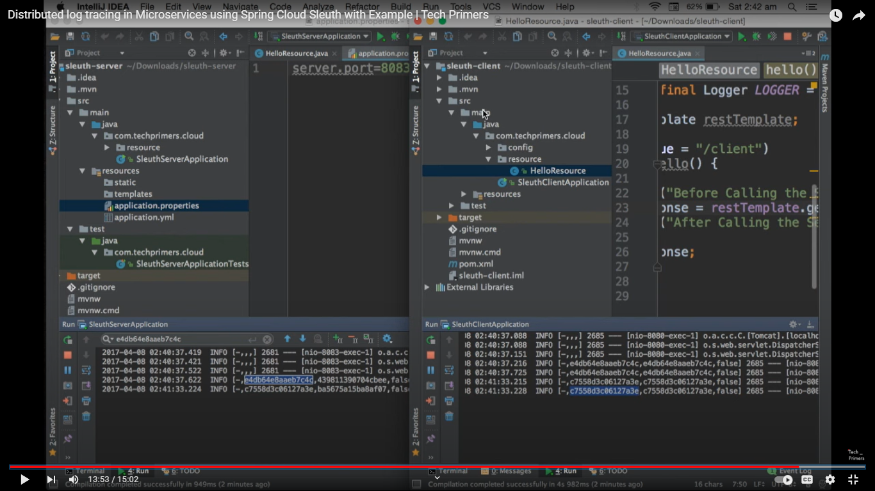

Trace id request id same in apI gateway & for this request check microservice by using span id.

Trace id is unquie & span id different.

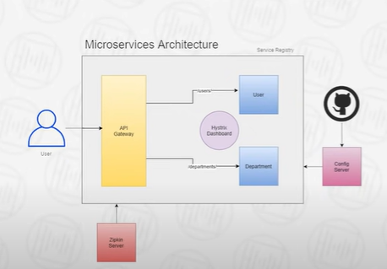

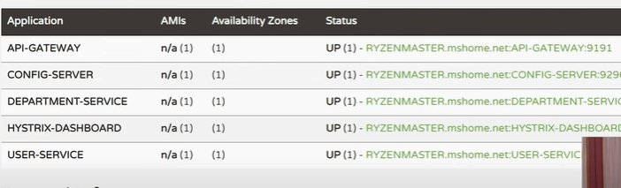

Three server API gateway & hystrix dashboard & config server common.

**What are Microservices?**

Microservices are a software architectural style in which a large application is built as a collection of small, independent services that communicate with each other over a network.

Each service is a self-contained unit of functionality that can be developed, tested, and deployed independently of the other services. This allows for more flexibility and scalability than a monolithic architecture, where all the functionality is contained in a single, large codebase.

Microservices can be written in different programming languages and use different technologies, as long as they can communicate with each other through a common API.

They are designed to be loosely coupled, meaning that changes to one service should not affect the other services. This makes it easier to update, maintain, and scale the application. Microservices architecture is best suited for large and complex applications that need to handle a high volume of traffic and need to be scaled horizontally.

**Key Components of a Microservices Architecture**

Key components of a microservices architecture include:

1. **Core Services**: Each service is a self-contained unit of functionality that can be developed, tested, and deployed independently of the other services.
2. **Service registry**: A service registry is a database of all the services in the system, along with their locations and capabilities. It allows services to discover and communicate with each other.
3. **API Gateway:** An API gateway is a single entry point for all incoming requests to the microservices. It acts as a reverse proxy, routing requests to the appropriate service and handling tasks such as authentication and rate limiting.
4. **Message bus:** A message bus is a messaging system that allows services to communicate asynchronously with each other. This can be done through protocols like HTTP, RabbitMQ, or Kafka.
5. **Monitoring and logging:** Monitoring and logging are necessary to track the health of the services and troubleshoot problems.
6. **Service discovery and load balancing:** This component is responsible for discovering service instances and directing traffic to the appropriate service instances based on load and availability.
7. **Continuous integration and continuous deployment (CI/CD):**To make the development and deployment process of microservices as smooth as possible, it is recommended to use a tool such as Jenkins, TravisCI, or CircleCI to automate the process of building, testing, and deploying microservices.

## Microservices Communication

Once we build these 3 microservices. Next, we'll see how these microservices communicate with each other. Well, there are different ways to make a REST API call from one microservice to another Microservice. For example, we can use a RestTemplate or WebClient or Spring cloud-provided open feign library. All right.  
  
Well, there are two types of communication styles. One is synchronous and another is asynchronous.  
  
In the case of synchronous, we can use the HTTP protocol to make an HTTP request from one microservice to the microservice.  
  
And in the case of asynchronous communication, we have to use a message broker for asynchronous communication between multiple microservices. For example, we can use RabbitMQ or Apache Kafka as a message broker in order to make an asynchronous communication between multiple microservices and each microservice in a microservices project can expose REST APIs.

## Registry and Discovery Pattern

Well, once we know how microservices communicate with each other, next you need to know how to implement a service Registry and discovery pattern in our microservices project.

Well, Spring Cloud provides a [**Spring Cloud Netflix Eureka Based Service Registry**](https://www.javaguides.net/2022/10/spring-boot-microservices-spring-cloud-netflix-eureka-.html) module that we can use to implement service registry and discovery patterns in our microservices project. Well, service Registry and discovery is a really essential pattern that we can use to avoid hard coding hostnames and ports.

## Config-Server to Externalize the Configurations

Next, we will implement a config server to externalize the configurations of all these three microservices into a central place which is the git repository.

Well, Spring cloud provides a Spring cloud config module that we can use to implement a config server to externalize the configuration files of all these three microservices into a central place. We are going to use the git repository as storage for the config server.

## API Gateway Pattern

Well, once we know how to use the config server to externalize the configuration files. Next, we have to implement an API gateway.

Well, API Gateway plays a very important role in our microservices architecture. So whenever a client wants to make a call to different microservices, the client has to remember the host names and ports of all these microservices. So there should be a solution where a client can send a request to the central component so that is where the API gateway comes into the picture. So whenever a client sends a request to the backend microservices, then the client has to send a request to the API gateway first, and then the API gateway based on the routing rules will route that request to the appropriate microservice. So this is how the API gateway plays an important role in a microservices architecture.

Well, Spring Cloud provides [**Spring Cloud Gateway module**](https://www.javaguides.net/2022/10/spring-boot-microservices-spring-cloud-api-gateway.html) to implement API gateway patterns in a microservices architecture.

## Distributed Tracing

Next, once you know how to implement an API gateway in a microservices project, next you can implement distributed tracing in a microservices architecture. Well, Spring Cloud provides a Spring Cloud sleuth module, which we can use to implement distributed tracing in our microservices project.  
  
Well, along with Spring Cloud Sleuth, we'll also use Zipkin to visualize the tracing log information in a user interface. Well, Zipkin provides a user interface to track and trace information through web applications.

## React Front Service

Next, you can use React/Angular to create a client-side service that will make a call to backend microservices.

## Circuit Breaker Pattern

Next, you can implement a circuit breaker pattern in an employee service because the employee service is internally calling department service, and let's say due to some reason, department service is down then employee service won't get a response from the department server, isn't it? And then again, employee service will send an internal server error to the API gateway and then API Gateway will send that response back to the client. All right. So in order to avoid this kind of issue, we can use a circuit breaker pattern.  
  
So this circuit breaker pattern helps the employee service to avoid continuous calls to the department service Whenever department service is done and this circuit breaker pattern will help employee service to return some default response back to the API Gateway and the API Gateway will send that default response to the client.  
  
All right. So this is a simple microservices architecture using Spring Boot and Spring Cloud.

**Service registry**:

**What we will build?**

We can use Netflix Eureka Server to create a Service Registry and make our microservices (*department-service* and *user-service*) as Eureka Clients so that as soon as we start a microservice it will get registered with Eureka Server automatically with a logical Service ID. Then, the other microservices, which are also Eureka Clients, can use Service ID to invoke REST endpoints.

**[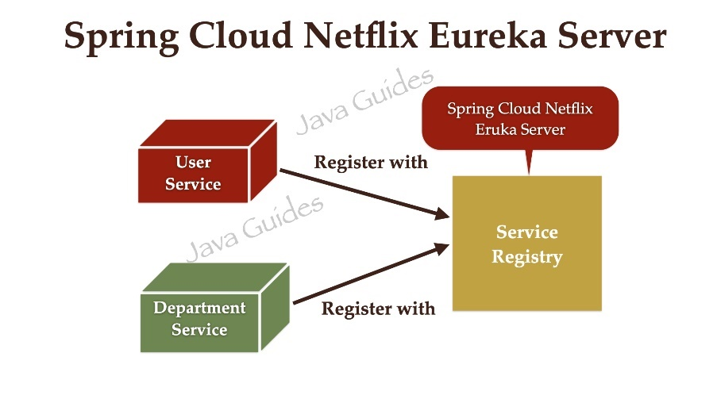](https://blogger.googleusercontent.com/img/b/R29vZ2xl/AVvXsEhcMZBv7AZQvpLEMR7kO9p7QAR6gN7EsYQnkDJz6rG0m2sgCnflPr4rZoXwW8HZv2Y7KU9mMa_JHVen62eYiG81hNZYm1saPpfuBJGjlD-XMS0sMkpn9nHQYbFSaBoXwnPzxA0ac8j-L0irv85FEuu7KG2jFzzWMtl6FRnY0bv1XTVYTugS_SK9lDGD/s1920/Spring%20Boot%20Microservices.012.jpeg)**

Spring Cloud makes it very easy to create a Service Registry and discover other services using Load Balanced *RestTemplate:*

@Bean

@LoadBalanced

public RestTemplate restTemplate(){

return new RestTemplate();

}

**Prerequisites**

Refer to the below tutorial to create department-service and user-service microservices:

[**Spring Boot Microservices Communication Example using RestTemplate**](https://www.javaguides.net/2022/10/spring-boot-microservices-communication-using-resttemplate.html).

**1. Create and Setup Spring boot project in IntelliJ IDEA**

Let us create a Service Registry using Netflix Eureka which is nothing but a SpringBoot application with a Eureka Server starter.

<dependency>

<groupId>org.springframework.cloud</groupId>

<artifactId>spring-cloud-starter-netflix-eureka-server</artifactId>

</dependency>

Let's create a Spring boot project using the [**spring initializr**](https://start.spring.io/).

Refer to the below screenshot to enter details while creating the spring boot application using the [**spring initializr**](https://start.spring.io/):

**[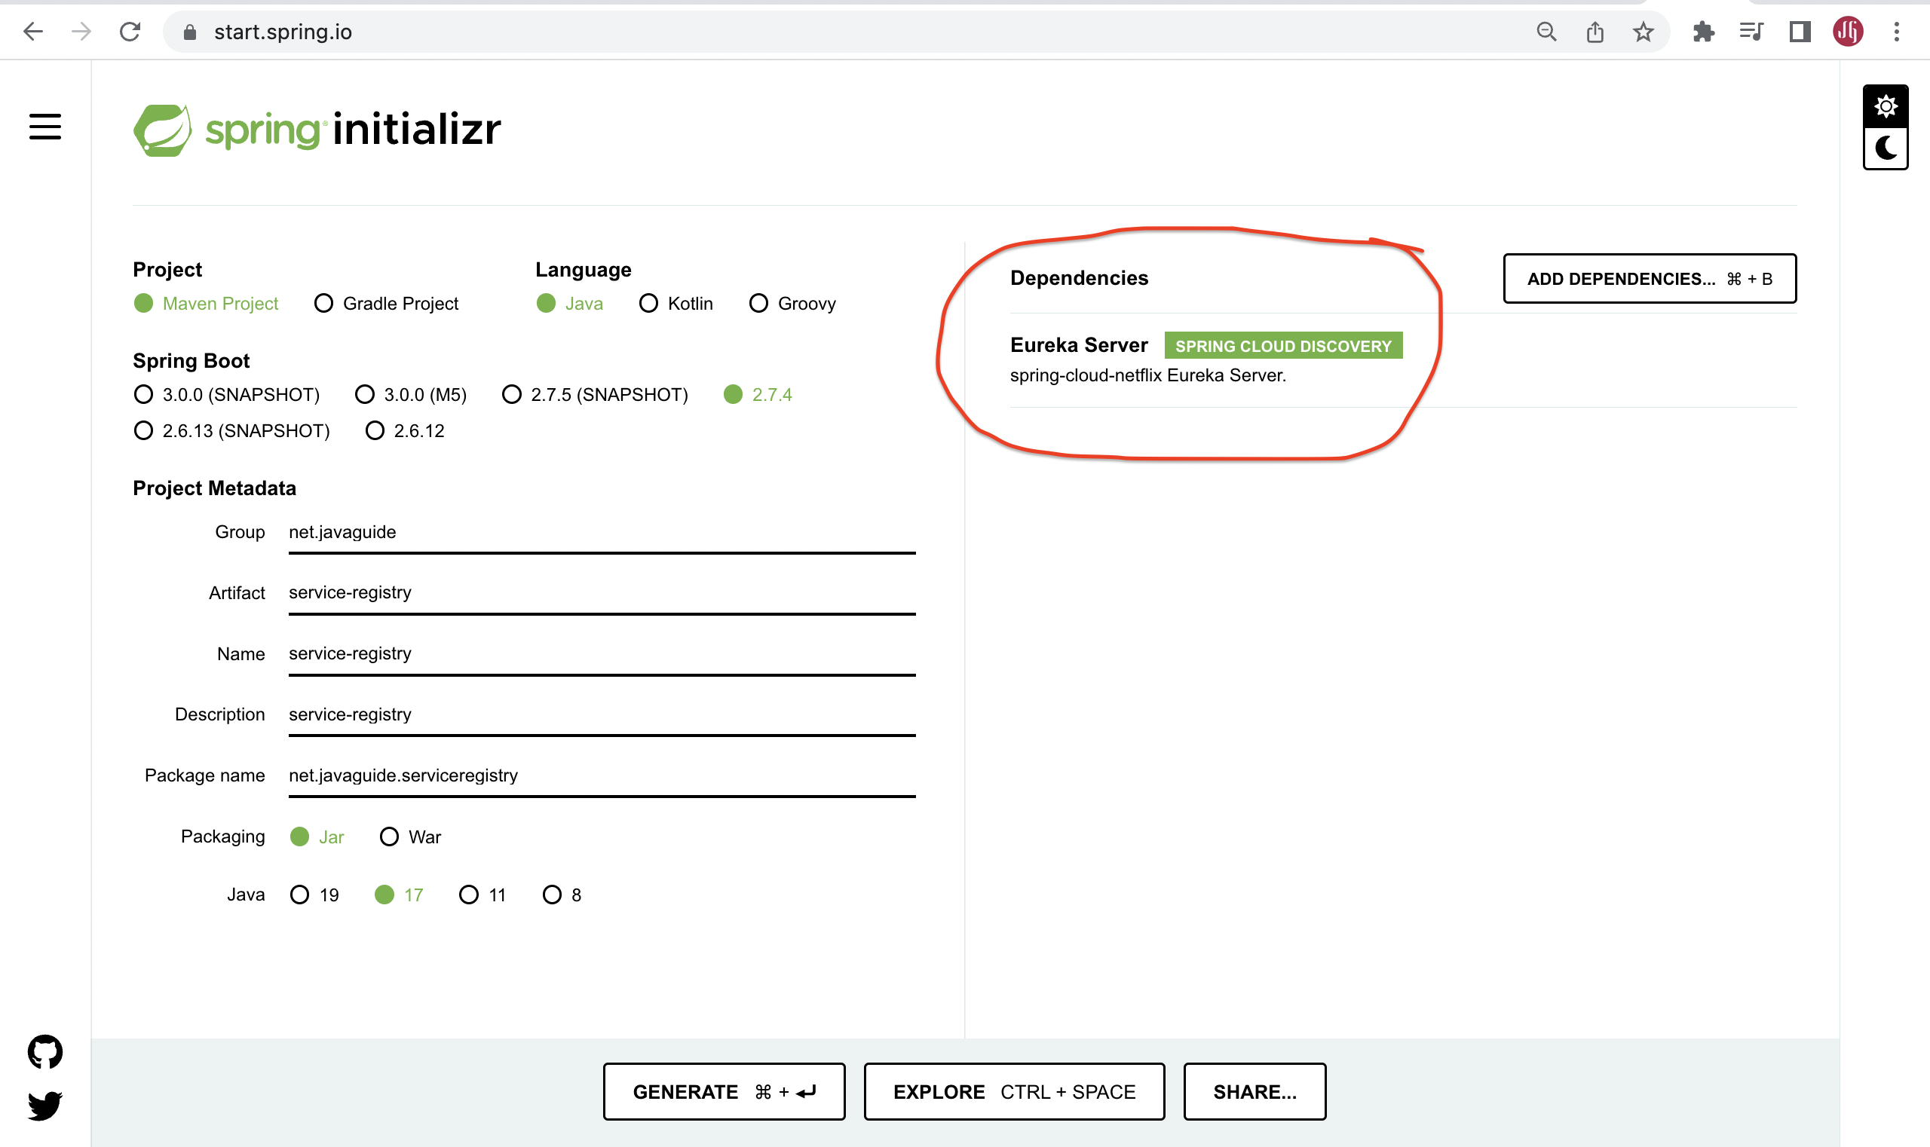](https://blogger.googleusercontent.com/img/b/R29vZ2xl/AVvXsEia_lrZoxT7dmGfBehXKeWI1FkD1eczuDDi2I-Un9u1VBgRMoPk2k_YcVg0qeDB5czDbdZg-XUDkz_nN9gXnmU3ZpMc8m6q0xsmzC8joqqPxu60hqLHxAG0wsR3bJyTbiMBz5jHWmM7zs0IssfIjO3sgU4cPqzYo8qpvfM2_i0dkKofcKGR2aO8zKPj/s2560/Screenshot%202022-10-02%20at%204.00.51%20PM.png)**

Click on Generate button to download the Spring boot project as a zip file. Unzip the zip file and import the Spring boot project in IntelliJ IDEA.

Here is the pom.xml file for your reference:

<?xml version="1.0" encoding="UTF-8"?>

<project xmlns="http://maven.apache.org/POM/4.0.0" xmlns:xsi="http://www.w3.org/2001/XMLSchema-instance"

xsi:schemaLocation="http://maven.apache.org/POM/4.0.0 https://maven.apache.org/xsd/maven-4.0.0.xsd">

<modelVersion>4.0.0</modelVersion>

<parent>

<groupId>org.springframework.boot</groupId>

<artifactId>spring-boot-starter-parent</artifactId>

<version>2.7.4</version>

<relativePath/> <!-- lookup parent from repository -->

</parent>

<groupId>net.javaguide</groupId>

<artifactId>service-registry</artifactId>

<version>0.0.1-SNAPSHOT</version>

<name>service-registry</name>

<description>service-registry</description>

<properties>

<java.version>17</java.version>

<spring-cloud.version>2021.0.4</spring-cloud.version>

</properties>

<dependencies>

<dependency>

<groupId>org.springframework.cloud</groupId>

<artifactId>spring-cloud-starter-netflix-eureka-server</artifactId>

</dependency>

<dependency>

<groupId>org.springframework.boot</groupId>

<artifactId>spring-boot-starter-test</artifactId>

<scope>test</scope>

</dependency>

</dependencies>

<dependencyManagement>

<dependencies>

<dependency>

<groupId>org.springframework.cloud</groupId>

<artifactId>spring-cloud-dependencies</artifactId>

<version>${spring-cloud.version}</version>

<type>pom</type>

<scope>import</scope>

</dependency>

</dependencies>

</dependencyManagement>

<build>

<plugins>

<plugin>

<groupId>org.springframework.boot</groupId>

<artifactId>spring-boot-maven-plugin</artifactId>

</plugin>

</plugins>

</build>

</project>

**2. Add @EnableEurekaServer annotation**

We need to add *@EnableEurekaServer* annotation to make our SpringBoot application a Eureka Server-based Service Registry.

package net.javaguides.serviceregistry;

import org.springframework.boot.SpringApplication;

import org.springframework.boot.autoconfigure.SpringBootApplication;

import org.springframework.cloud.netflix.eureka.server.EnableEurekaServer;

@SpringBootApplication

@EnableEurekaServer

public class ServiceRegistryApplication {

public static void main(String[] args) {

SpringApplication.run(ServiceRegistryApplication.class, args);

}

}

**3. Disable Eureka Server as Eureka Client**

By default, each Eureka Server is also a Eureka client and needs at least one service URL to locate a peer. As we are going to have a single Eureka Server node (Standalone Mode), we are going to disable this client-side behavior by configuring the following properties in the *application.properties* file.

spring.application.name=service-registry

server.port=8761

eureka.client.register-with-eureka=false

eureka.client.fetch-registry=false

**4. Launch Eureka Server (Demo)**

Netflix Eureka Service provides UI where we can see all the details about registered services.

Now run *ServiceRegistryApplication* and access [**http://localhost:8761**](http://localhost:8761/) which will display the UI similar to the below screenshot.

**[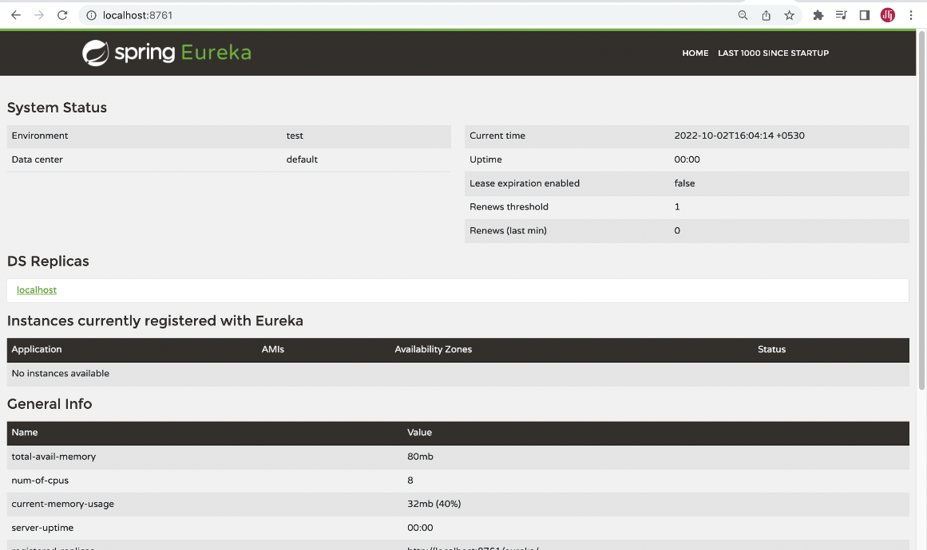](https://blogger.googleusercontent.com/img/b/R29vZ2xl/AVvXsEjywBofNaOkTGIWkeG-Ec7xaFW9mhGoaeFlk_Yx_iWLNzZm1iv_ohfDpcooZErA6ox-JxqrDRHCU89euHr3I7TjGr1dj7j1wdAyWb0SXbWcGgovtgr5GlFW2pG5BIfIZRe4ZriwQiI2a0fg4reaVnmypJGsZIiDbYUos9a2caeAUGfvODcxnBPV7FsM/s2560/Screenshot%202022-10-02%20at%204.04.34%20PM.png)**

**5. Registering Department-Service Microservice as Eureka Client**

Refer to this tutorial to create department-service and user-service microservices: [**Spring Boot Microservices Communication Example using RestTemplate**](https://www.javaguides.net/2022/10/spring-boot-microservices-communication-using-resttemplate.html).

Let us make this *department-service* as a Eureka Client and register with the Eureka Server.

Add the Eureka Discovery starter to *department-service*:

<dependency>

<groupId>org.springframework.cloud</groupId>

<artifactId>spring-cloud-starter-netflix-eureka-client</artifactId>

</dependency>

Also, add the Spring cloud dependencies:

<dependencyManagement>

<dependencies>

<dependency>

<groupId>org.springframework.cloud</groupId>

<artifactId>spring-cloud-dependencies</artifactId>

<version>${spring-cloud.version}</version>

<type>pom</type>

<scope>import</scope>

</dependency>

</dependencies>

</dependencyManagement>

Add version as property:

<properties>

<java.version>17</java.version>

<spring-cloud.version>2021.0.4</spring-cloud.version>

</properties

With *spring-cloud-starter-netflix-eureka-client* on the classpath, we just need to configure *eureka.client.service-url.defaultZone* property in *application.properties* to automatically register with the Eureka Server.

spring.application.name=DEPARTMENT-SERVICE

eureka.instance.client.serviceUrl.defaultZone=http://localhost:8761/eureka/

When a service is registered with Eureka Server it keeps sending heartbeats for certain intervals. If the Eureka server didn’t receive a heartbeat from any service instance it will assume the service instance is down and take it out from the pool.

**6. Run department-service Eureka Client (Demo)**

With this configuration in place, start *department-service* and visit [**http://localhost:8761**](http://localhost:8761/).

You should see that *department-service* is registered with SERVICE ID as DEPARTMENT-SERVICE. You can also notice the status as UP(1) which means the services are up and running and one instance of *department-service* is running.

**[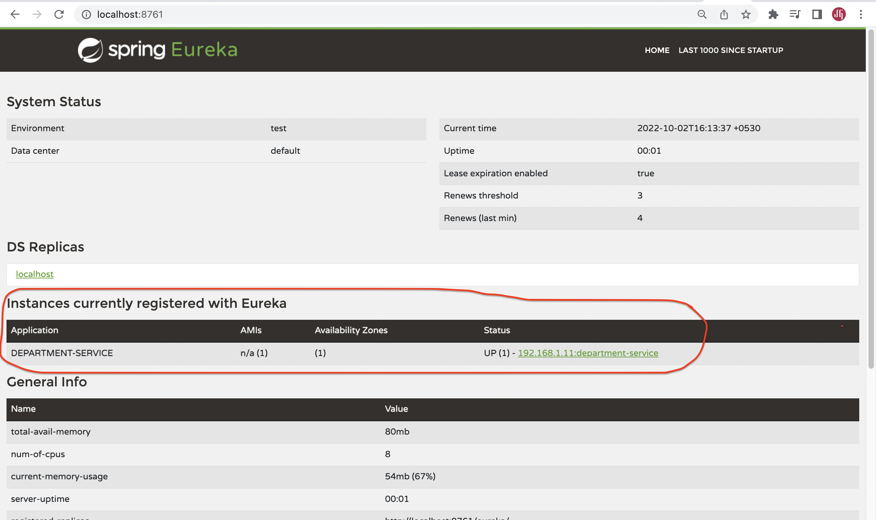](https://blogger.googleusercontent.com/img/b/R29vZ2xl/AVvXsEi-yqg5yTS-Vesuftw7EGQJumye42QUyP3o1F8TSItNz_a6RzjK84N_t-51GBeK7vxy64kGgq5YwyLsGyxqWSSHIo7avg1_ZQCwOZwaAN07kNl-whqaO8jvl6cL4VCeBJ2gr56NSOvrztBwIFtTmPI-ShhW3qhOwOwT7vHPyrkf54wjtQpwHUqyvfnC/s2560/Screenshot%202022-10-02%20at%204.13.46%20PM.png)**

**7. Registering User-Service Microservice as Eureka Client**

Refer to this tutorial to create department-service and user-service microservices: [**Spring Boot Microservices Communication Example using RestTemplate**](https://www.javaguides.net/2022/10/spring-boot-microservices-communication-using-resttemplate.html).

Let us make this *user-service* as a Eureka Client and register with the Eureka Server.

Add the Eureka Discovery starter to *user-service*:

<dependency>

<groupId>org.springframework.cloud</groupId>

<artifactId>spring-cloud-starter-netflix-eureka-client</artifactId>

</dependency>

Also, add the Spring cloud dependencies:

<dependencyManagement>

<dependencies>

<dependency>

<groupId>org.springframework.cloud</groupId>

<artifactId>spring-cloud-dependencies</artifactId>

<version>${spring-cloud.version}</version>

<type>pom</type>

<scope>import</scope>

</dependency>

</dependencies>

</dependencyManagement>

Add version as property:

<properties>

<java.version>17</java.version>

<spring-cloud.version>2021.0.4</spring-cloud.version>

</properties

With *spring-cloud-starter-netflix-eureka-client* on the classpath, we just need to configure *eureka.client.service-url.defaultZone* property in *application.properties* to automatically register with the Eureka Server.

spring.application.name=USER-SERVICE

eureka.instance.client.serviceUrl.defaultZone=http://localhost:8761/eureka/

**8. Run user-service Eureka Client (Demo)**

With this configuration in place, start user-service and visit [**http://localhost:8761**](http://localhost:8761/). You should see *user-service* is registered with SERVICE ID as USER-SERVICE.

You can also notice the status as UP(1) which means the services are up and running and one instance of *user-service* is running.

**[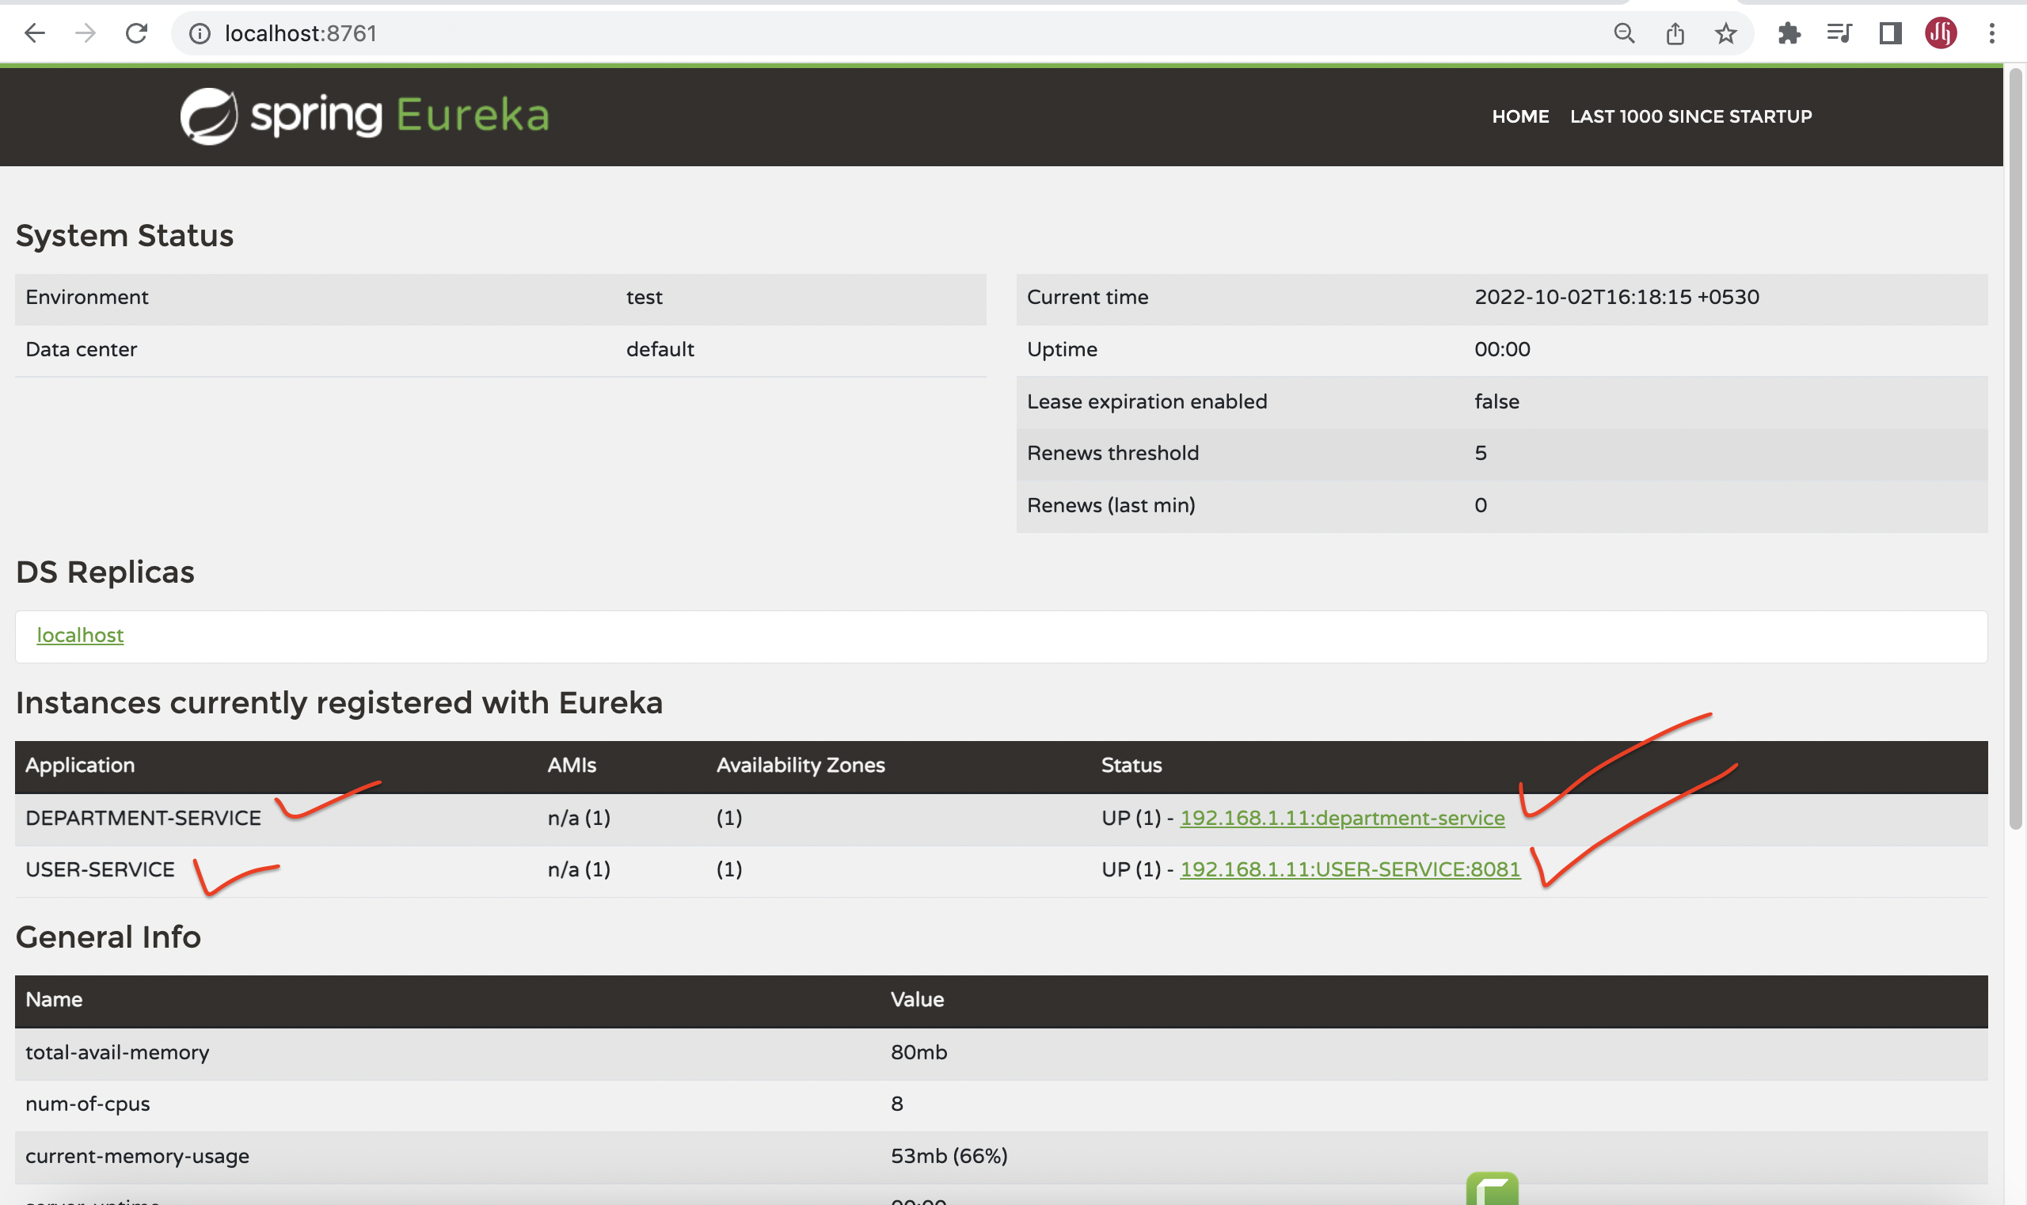](https://blogger.googleusercontent.com/img/b/R29vZ2xl/AVvXsEjJAT3MxvQgVYr8i4-yZOtLURB-_55uNt7N3lcIGSnjpU4TChMW9bBVzARJUDmyH2uhFSRV-zS20K7DJxNQvZffMoHwYkQMc63fscPJWID044mNCVmc7P6_mDvtdbGFbz70t-SW7C8rxquDyg4nYcY0uFK4ZttmriG4id5P9fQ_btq40QmUlNlxQjYN/s2560/Screenshot%202022-10-02%20at%204.18.22%20PM.png)**

**Multiple Instances of Department-Service**

Let us start another instance of *department-service* on a different port using the following command.

java -jar -Dserver.port=8082 department-service-0.0.1-SNAPSHOT.jar

Suppose we want to invoke the *department-service* REST endpoint from the *user-service*. We can use *RestTemplate* to invoke the REST endpoint but there are 2 instances running.

We can register RestTemplate as a Spring bean with *@LoadBalanced* annotation:

@Bean

@LoadBalanced

public RestTemplate restTemplate(){

return new RestTemplate();

}

The *RestTemplate* with *@LoadBalanced* annotation will internally use **Ribbon LoadBalancer** to resolve the ServiceID and invoke the REST endpoint using one of the available servers.

Change the URL in *UserServiceImpl* class:

ResponseEntity<DepartmentDto> responseEntity = restTemplate

.getForEntity("http://DEPARTMENT-SERVICE/api/departments/" + user.getDepartmentId(),

DepartmentDto.class);

With this kind of automatic Service Registration and Discovery mechanism, we no need to worry about how many instances are running and what are their hostnames and ports, etc

API Gateway:

# Spring Cloud Gateway Overview

Spring Cloud Gateway provides a library for building an API Gateway on top of Spring WebFlux. Spring Cloud Gateway aims to provide a simple, yet effective way to route to APIs and provide cross-cutting concerns to them such as security, monitoring/metrics, and resiliency.

**[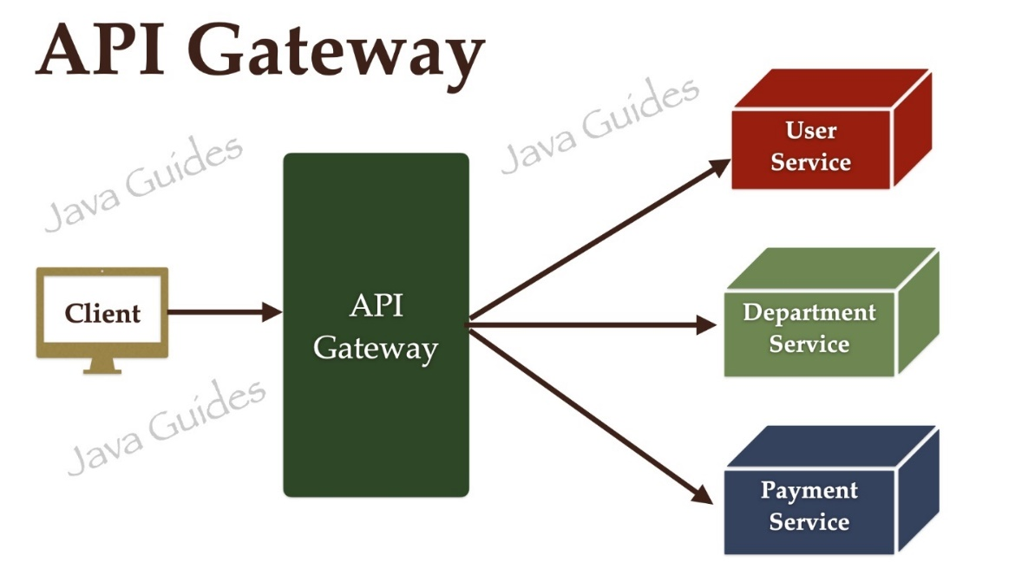](https://blogger.googleusercontent.com/img/b/R29vZ2xl/AVvXsEhuiQ_b_VUfLp-lICNcniFKezOgMv2cRsOPd5KVwP6NZiuYMcWgAiojvGRHqhu5i6OpJ6As4IF4yPg9EnKXqfgWQ-uODxV8-ovrW041Wa8vgtfjhuTzPoWjyiWIABeaDVSzmDNekDujRd_APSDDQgkgFhiMFc3OQtERlN-ESqIO5_zRUNgp9LuOQl7a/s1920/Spring%20Boot%20Microservices.009.jpeg)**

**The Spring Cloud Gateway has three important parts to it:**

**Route** − These are the building blocks of the gateway which contain the URL to which the request is to be forwarded to and the predicates and filters that are applied to the incoming requests.

**Predicate** − These are the set of criteria that should match for the incoming requests to be forwarded to internal microservices. For example, a path predicate will forward the request only if the incoming URL contains that path.

**Filters** − These act as the place where you can modify the incoming requests before sending the requests to the internal microservices or before responding back to the client.

To know more read [**Spring Cloud Gateway documentation**](https://docs.spring.io/spring-cloud-gateway/docs/current/reference/html/).

# Prerequisites

Refer to the below tutorial to create department-service and user-service microservices and configure Netflix Eureka Service Registry:

[**Spring Boot Microservices - Spring Cloud Netflix Eureka-based Service Registry**](https://www.javaguides.net/2022/10/spring-boot-microservices-spring-cloud-netflix-eureka-.html)

# 1. Create and Setup Spring Boot Project in IntelliJ IDEA

Let's create a Spring boot project using the [**spring initializr**](https://start.spring.io/).

Refer to the below screenshot to enter details while creating the spring boot application using the [**spring initializr**](https://start.spring.io/):

**[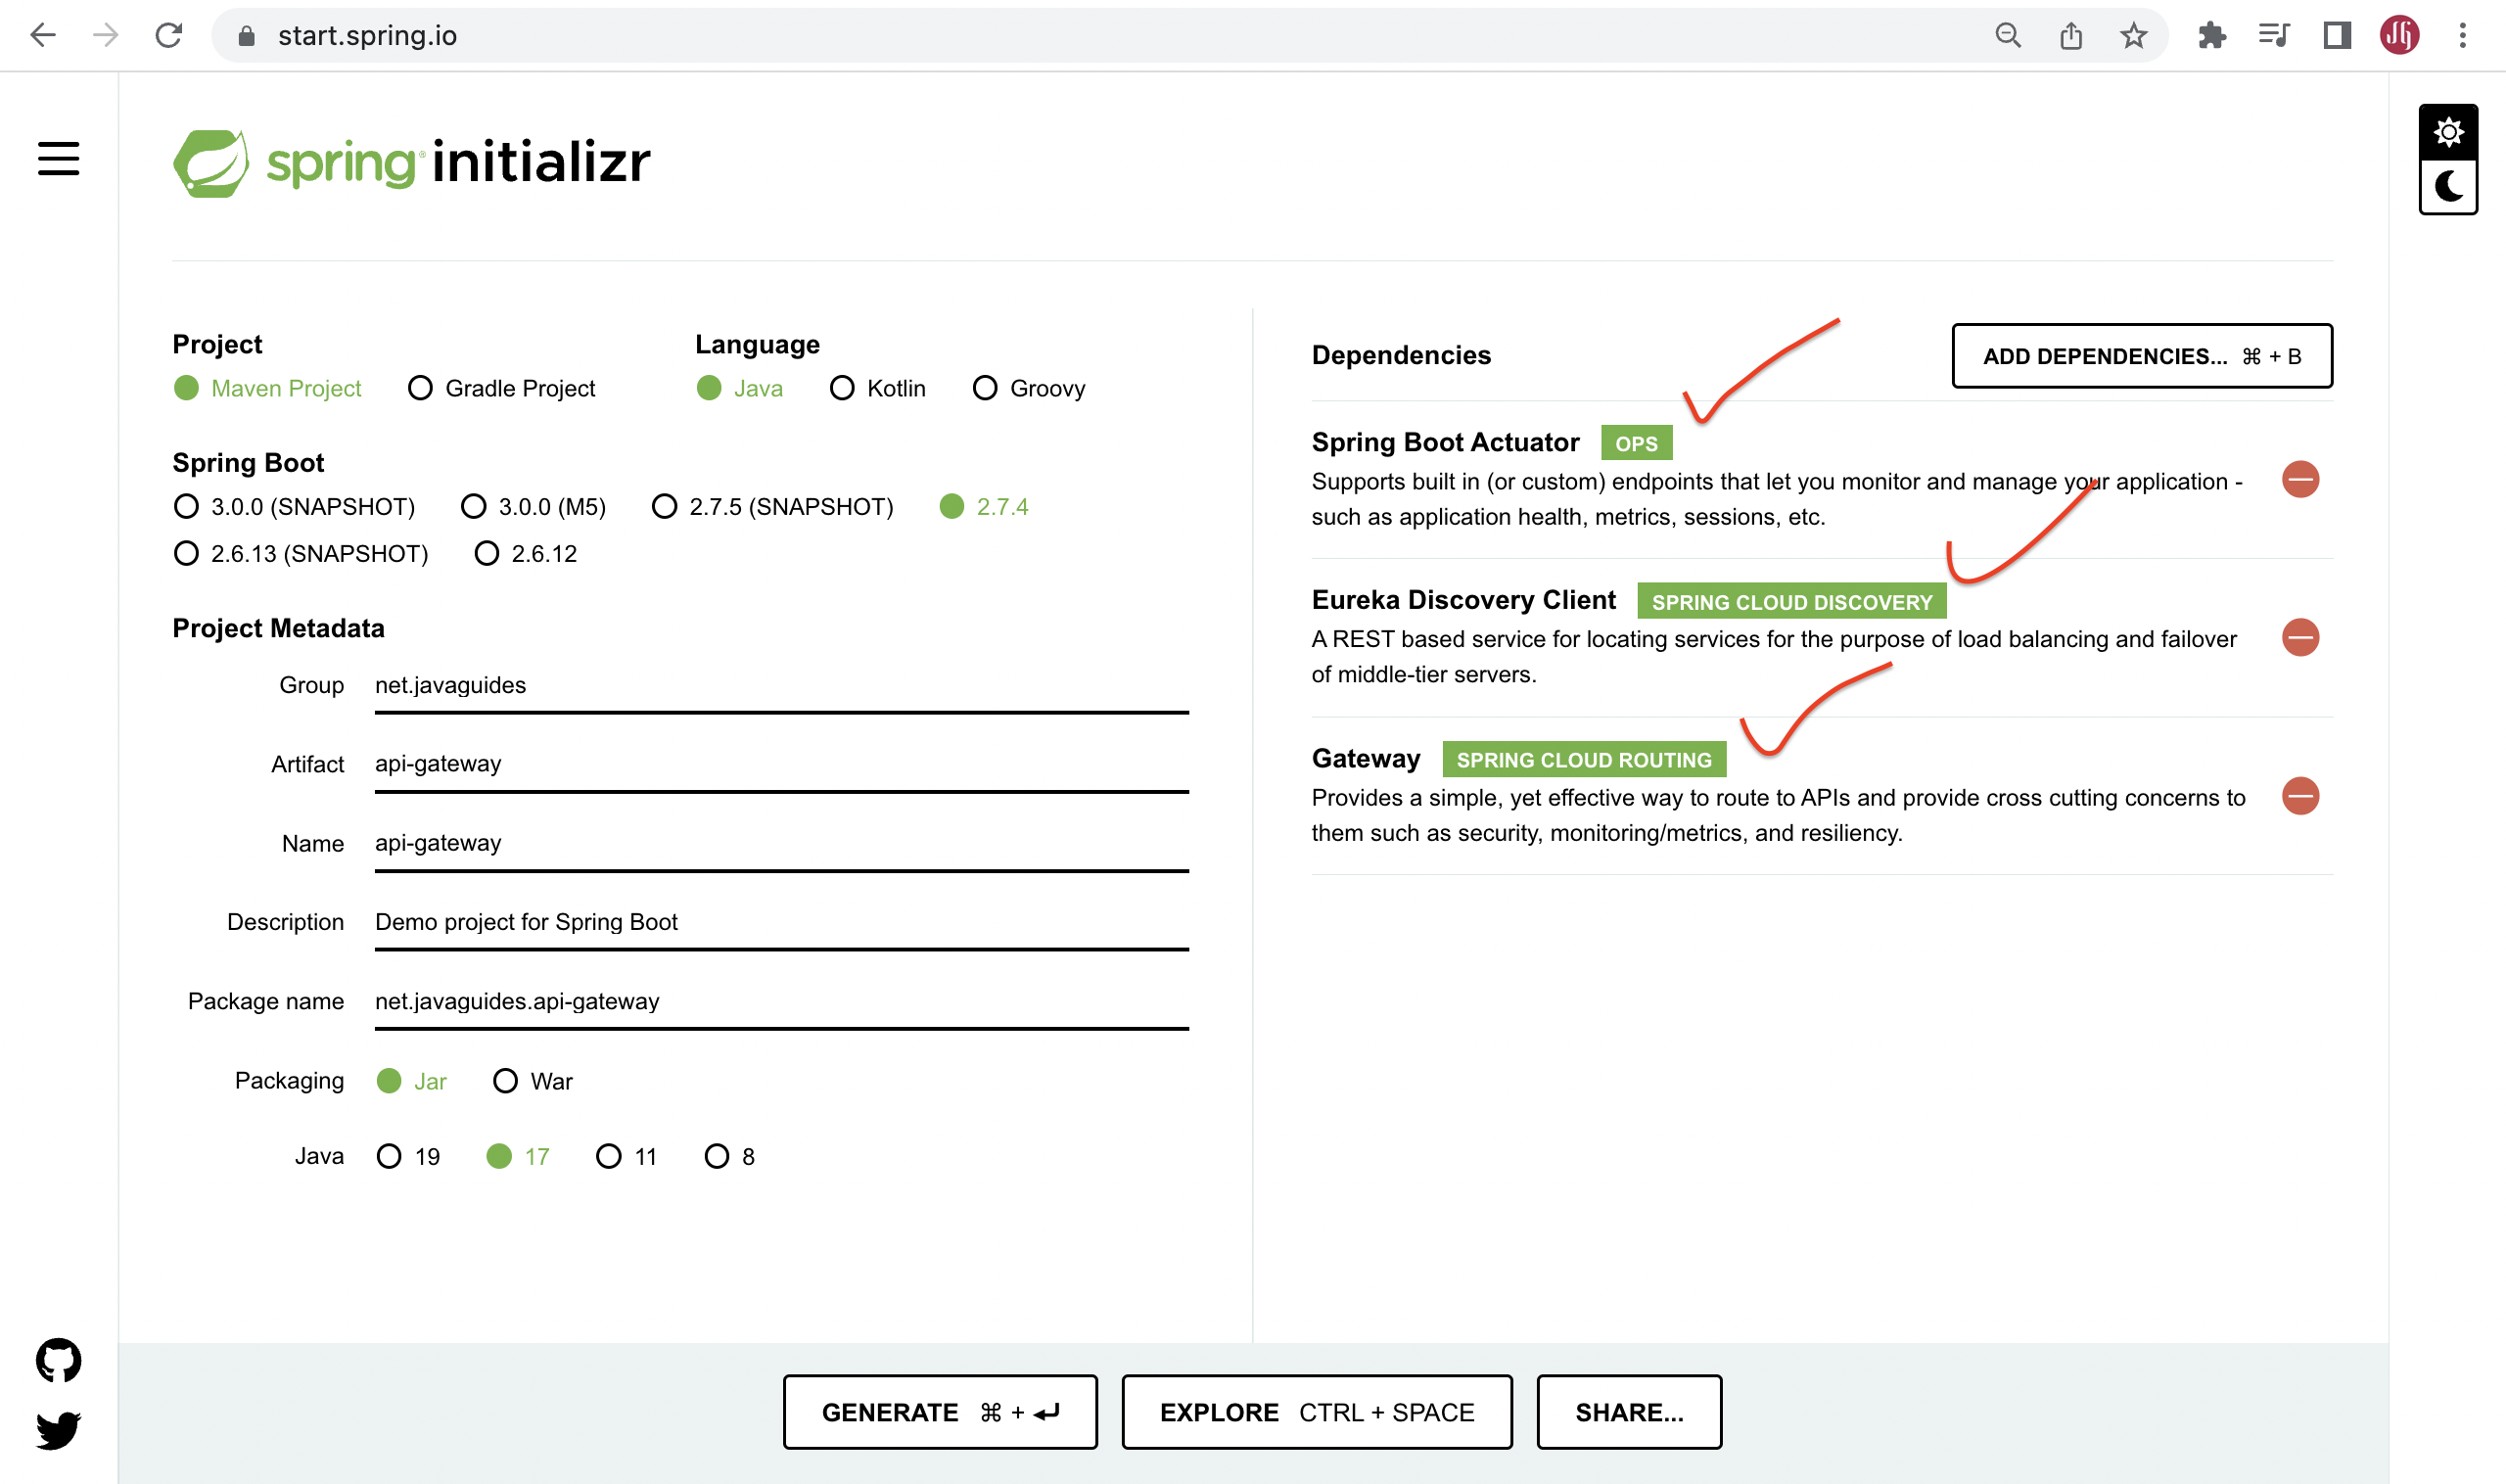](https://blogger.googleusercontent.com/img/b/R29vZ2xl/AVvXsEjyAj1hnmFt_7D-T7sjcfCeOglW4CGLbEAXXHXGAZd1hDr4E-FvalWZo5IO3r6NLw9wvpd5lJQTzwrqO23R1EWKpsEZkp7pmIefl4snBigqyXp2ylI6kds2CAS_K7N19CMykb3esjfCygI8rckx1rUvjm3s9Pn1bXPRfgRmPBDEj_Qenadu8fv3Ia2g/s2560/Screenshot%202022-10-02%20at%208.06.28%20PM.png)**

Click on Generate button to download the Spring boot project as a zip file. Unzip the zip file and import the Spring boot project in IntelliJ IDEA.

Here is the pom.xml file for your reference:

<?xml version="1.0" encoding="UTF-8"?>

<project xmlns="http://maven.apache.org/POM/4.0.0" xmlns:xsi="http://www.w3.org/2001/XMLSchema-instance"

xsi:schemaLocation="http://maven.apache.org/POM/4.0.0 https://maven.apache.org/xsd/maven-4.0.0.xsd">

<modelVersion>4.0.0</modelVersion>

<parent>

<groupId>org.springframework.boot</groupId>

<artifactId>spring-boot-starter-parent</artifactId>

<version>2.7.4</version>

<relativePath/> <!-- lookup parent from repository -->

</parent>

<groupId>nt.javaguides</groupId>

<artifactId>api-gateway</artifactId>

<version>0.0.1-SNAPSHOT</version>

<name>api-gateway</name>

<description>api-gateway</description>

<properties>

<java.version>17</java.version>

<spring-cloud.version>2021.0.4</spring-cloud.version>

</properties>

<dependencies>

<dependency>

<groupId>org.springframework.boot</groupId>

<artifactId>spring-boot-starter-actuator</artifactId>

</dependency>

<dependency>

<groupId>org.springframework.cloud</groupId>

<artifactId>spring-cloud-starter-gateway</artifactId>

</dependency>

<dependency>

<groupId>org.springframework.cloud</groupId>

<artifactId>spring-cloud-starter-netflix-eureka-client</artifactId>

</dependency>

<dependency>

<groupId>org.springframework.boot</groupId>

<artifactId>spring-boot-starter-test</artifactId>

<scope>test</scope>

</dependency>

</dependencies>

<dependencyManagement>

<dependencies>

<dependency>

<groupId>org.springframework.cloud</groupId>

<artifactId>spring-cloud-dependencies</artifactId>

<version>${spring-cloud.version}</version>

<type>pom</type>

<scope>import</scope>

</dependency>

</dependencies>

</dependencyManagement>

<build>

<plugins>

<plugin>

<groupId>org.springframework.boot</groupId>

<artifactId>spring-boot-maven-plugin</artifactId>

</plugin>

</plugins>

</build>

</project>

Now we have all the dependencies that we need to have in our API gateway application. So now let’s configure the Routes and other API gateway-specific configurations to use in our project.

# 2. Enable Eureka Client using @EnableEurekaClient

The *@EnableEurekaClient* annotation makes your Spring Boot application act as a Eureka client.

package nt.javaguides.apigateway;

import org.springframework.boot.SpringApplication;

import org.springframework.boot.autoconfigure.SpringBootApplication;

import org.springframework.cloud.netflix.eureka.EnableEurekaClient;

@SpringBootApplication

@EnableEurekaClient

public class ApiGatewayApplication {

public static void main(String[] args) {

SpringApplication.run(ApiGatewayApplication.class, args);

}

}

Don't miss this step, you have to configure the API gateway as a Eureka Client for this project. Otherwise, you couldn’t use discovery functions to identify the correct API from the service registry.

# 3. Configure Eureka Server URL

To register the Spring Boot application into Eureka Server we need to add the following configuration in our *application.properties* file and specify the Eureka Server URL in our configuration.

spring.application.name=API-GATEWAY

server.port=9191

eureka.instance.client.serviceUrl.defaultZone=http://localhost:8761/eureka/

management.endpoints.web.exposure.include=\*

# 4. Configuring API Gateway Routes With Spring Cloud Gateway

Now, you might be wondering how API Gateway knows the hostname or IP and port of microservices right.

When a client sends a request to the API gateway, It will discover the correct service IP and PORT using the service registry to communicate and route the request.

Let's configure Routes using properties:

spring.application.name=API-GATEWAY

server.port=9191

eureka.instance.client.serviceUrl.defaultZone=http://localhost:8761/eureka/

management.endpoints.web.exposure.include=\*

spring.cloud.gateway.routes[0].id=USER-SERVICE

spring.cloud.gateway.routes[0].uri=lb://USER-SERVICE

spring.cloud.gateway.routes[0].predicates[0]=Path=/api/users/\*\*

spring.cloud.gateway.routes[1].id=DEPARTMENT-SERVICE

spring.cloud.gateway.routes[1].uri=lb://DEPARTMENT-SERVICE

spring.cloud.gateway.routes[1].predicates[0]=Path=/api/departments/\*\*

spring.cloud.gateway.routes[2].id=DEPARTMENT-SERVICE

spring.cloud.gateway.routes[2].uri=lb://DEPARTMENT-SERVICE

spring.cloud.gateway.routes[2].predicates[0]=Path=/message/\*\*

What are the properties that we set for API gateway routes?

* id – This is just an identification of the routes.
* URI – Here we can use either URL [**http://localhost:8080**](http://localhost:8080/) or lb://DEPARTMENT-SERVICE. But if we need to use the inbuilt load balancer on the Netflix Eureka server, we should use lb://DEPARTMENT-SERVICE, then the API registry will take over the request and show a load-balanced request destination to the API gateway.
* predicates – In here we can set multiple paths to identify a correct routing destination. Eg:- If the API gateway gets and request like [**http://localhost:9191/api/users/1**](http://localhost:9191/api/users/1) then it will be routed into [**http://localhost:8081/api/users/1**](http://localhost:8081/api/users/1).

# 5. Run All the Microservices

Department Service running on port: [**http://localhost:8080**](http://localhost:8080/)

User Service running on port: [**http://localhost:8081**](http://localhost:8081/)

API Gateway service running on port: [**http://localhost:9191**](http://localhost:9191/)

Service Registry service running on port: [**http://localhost:8761**](http://localhost:8761/)

# 6. Verify Registered Instances in Service Registry

Go to the browser and hit this link in a new tab: [**http://localhost:8761**](http://localhost:8761/)

**[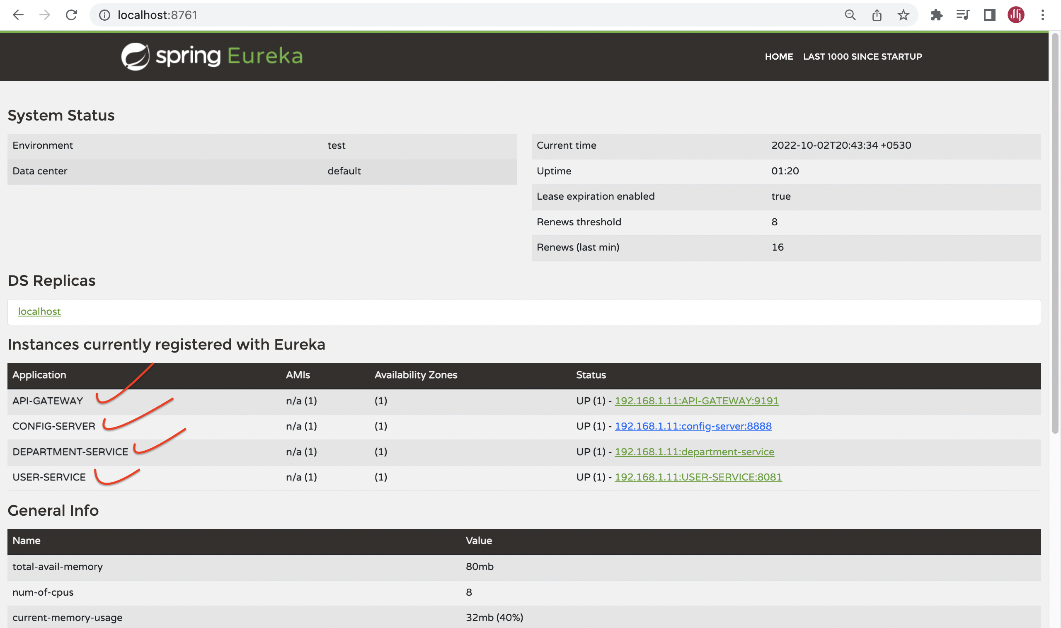](https://blogger.googleusercontent.com/img/b/R29vZ2xl/AVvXsEhEpeXrjqfEczIif5gu9Mp6NFFS42Z9M5kD6I470cqaoucrq0ymO9uX99c7RT_duwO1_sNDwpc6zZBEqQxqbx6iB5N6wZ0MEZi-PGhBzOSv2MvlH17U2UsCk1hBYcF2DH9RVY_VE9MZbMsv3_-hwDaikC0Wk1ww8IBpwiJFraRPOe9k_-jDREhMur-N/s2560/Screenshot%202022-10-02%20at%208.44.29%20PM.png)**

# 7. Testing API Gateway using Postman Client

## Get Department REST API:

Note that we are using API-Gateway service port (9191) to call department-service API (port 8080)

Department Service running on port: [**http://localhost:8080**](http://localhost:8080/)

API Gateway service running on port: [**http://localhost:9191**](http://localhost:9191/)

API Gateway route the request from [**http://localhost:9191/api/departments/1**](http://localhost:9191/api/departments/1) to [**http://localhost:8080/api/departments/1**](http://localhost:8080/api/departments/1)

**[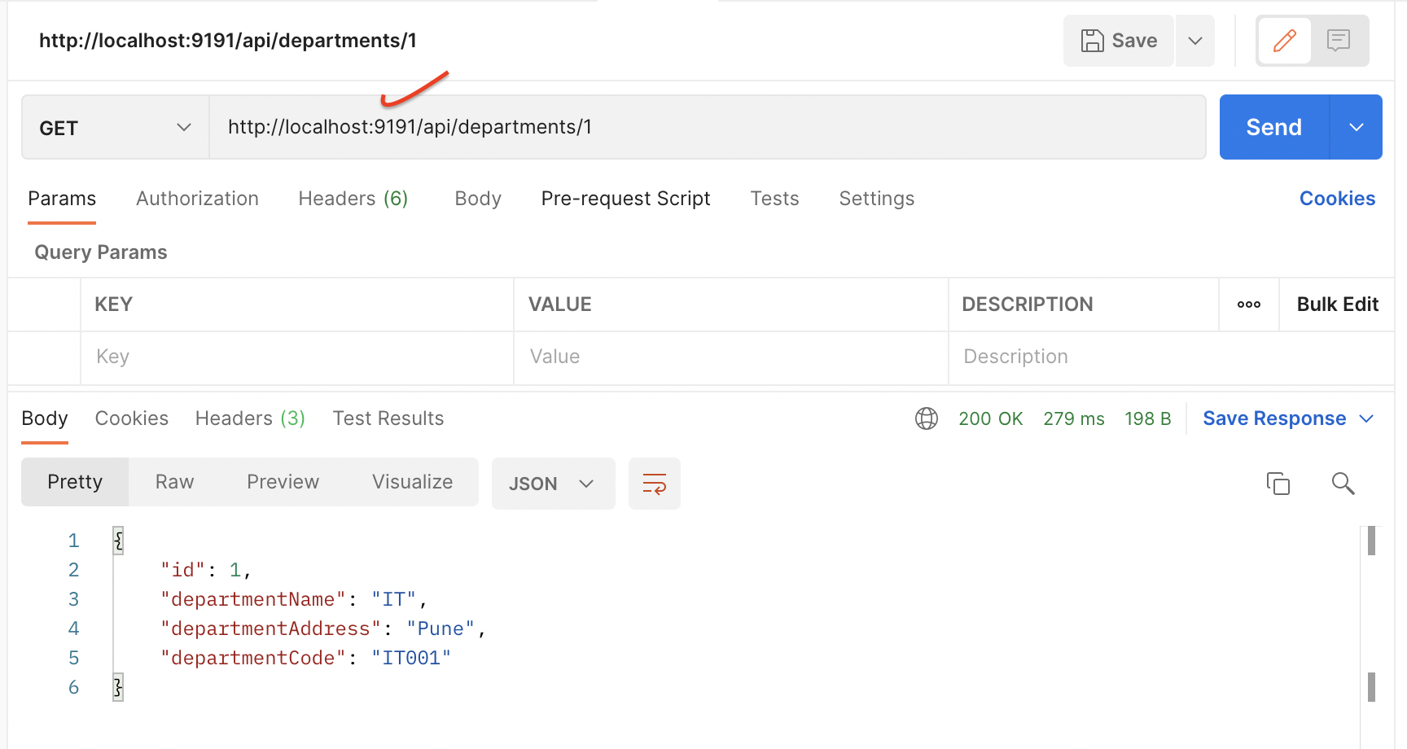](https://blogger.googleusercontent.com/img/b/R29vZ2xl/AVvXsEjzX6LaS1T_f19LlGLO8OYJFiBZFmZ9UE0f8hsqSMEKdE2PCZuP2XxZnJ3KnzjNR9Ah91WFc0gHzG8p2g_6beNArt9WJwttHbVITeOlERRVmyM9syoHEDIps1UoroFqE9CnJGyl3dwN-eoJIR2Ehstur4uz2Ud6UC0iIRqt_L7OWNJbD__AVflwx4s0/s1728/Screenshot%202022-10-02%20at%208.46.55%20PM.png)**

## Get User REST API:

Note that we are using API-Gateway service port (9191) to call the user-service API port (8081).

User Service running on port: [**http://localhost:8081**](http://localhost:8081/)

API Gateway service running on port: [**http://localhost:9191**](http://localhost:9191/)

API Gateway route the request from [**http://localhost:9191/api/users/1**](http://localhost:9191/api/users/1) to [**http://localhost:8081/api/users/1**](http://localhost:8081/api/users/1)

**[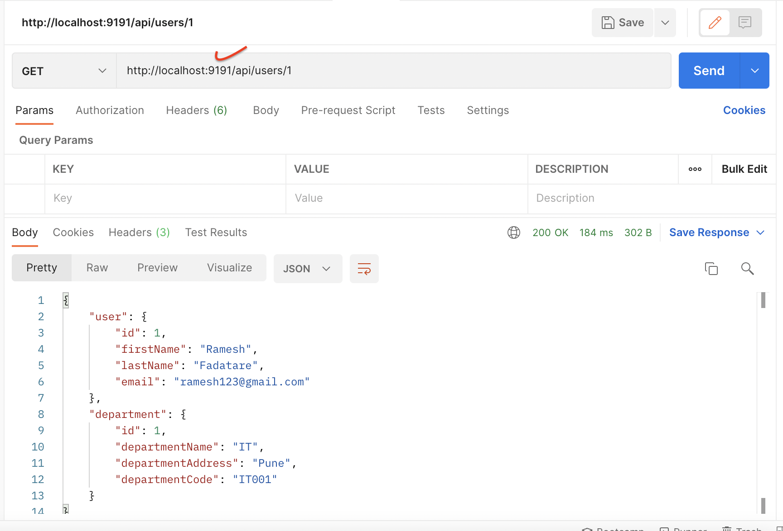](https://blogger.googleusercontent.com/img/b/R29vZ2xl/AVvXsEjN74GYIl1WWhMoKskSWnic7F7In5-D8mW4Wq1Vaze_cxdUYBsBfyS4ZFUov2J1Bb73Gi6N123l3gPpOcrHVMA45HRBP1fmOjnXr2nh-k6RqCQ0DWj9xlQBGo76SYoxQCHFzawBBfme3ZRkV0VD3aXfRuDbEFQ1QllbuinFWQSp1Tu7hRVRbYhMqfUb/s1728/Screenshot%202022-10-02%20at%208.53.02%20PM.png)**

Config Server:

## Problem

In the microservices project, there could be a large number of microservices and multiple instances of those microservices are running. Updating configuration properties and restarting all those instances manually or even with automated scripts may not be feasible.

## Solution

Spring Cloud Config addresses this problem.  
  
We can create a Spring Cloud Config Server which provides the configuration values for all of our microservices. We can use git, svn, database, or Consul as a backend to store the configuration parameters.

Next, we can configure the location of the Spring Cloud Config server in our microservice so that it will load all the properties when we start the application. In addition to that, whenever we update the properties we can invoke the *actuator/refresh* the REST endpoint in our microservice so that it will reload the configuration changes without requiring us to restart the application.

# What we will build?

Let's create Spring Cloud Config Server using Git as a backend to store the configurations. Spring Cloud Config Server is nothing but a SpringBoot project.

**[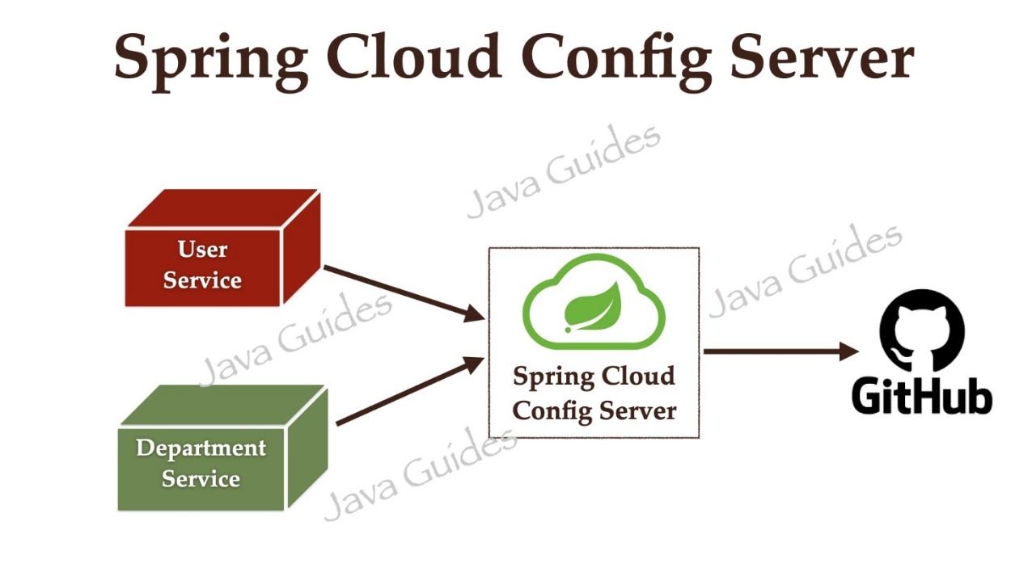](https://blogger.googleusercontent.com/img/b/R29vZ2xl/AVvXsEjl7cBF8H9GpKgotQ_9ChhDS6nNRTz7O4RMWUZtdnKqZPD2l9s3laVrVDMSbqI2DVPoahX4eZS7jtiei4Jyd698JFizfmNhxc8XrEJcjNLHA1MnXvmbwCqLBL_4-8LQnswg3FC9M1XOgtJ_PGT4yKjtdBGzBs4GNHQ1gttbqBqpL6A5L4_giQ48QlO2/s1920/Spring%20Boot%20Microservices.010.jpeg)**

# Prerequisites

Refer to the below tutorial to create department-service and user-service microservices:

[**Spring Boot Microservices Communication Example using RestTemplate**](https://www.javaguides.net/2022/10/spring-boot-microservices-communication-using-resttemplate.html).

# 1. Create and Setup Spring Boot Project in IntelliJ IDEA

Let's create a Spring boot project using the [**spring initializr**](https://start.spring.io/).

Refer to the below screenshot to enter details while creating the spring boot application using the [**spring initializr**](https://start.spring.io/):

**[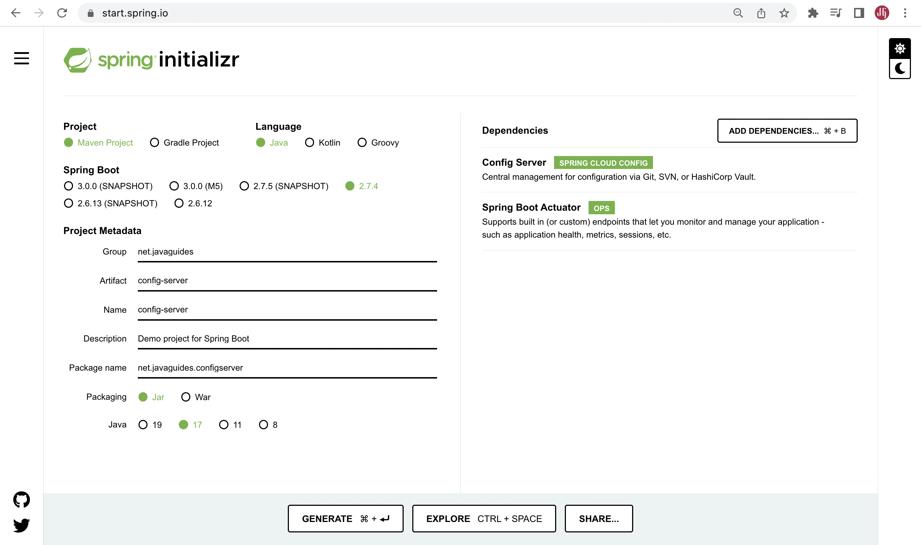](https://blogger.googleusercontent.com/img/b/R29vZ2xl/AVvXsEis95nts1pWDhb3HVYjKugCmf463eBihYaDh-XkazLyGLpzL6h6vlkGjWryN6vah4dblvwqVw_M8ViBxrDRrT6Gv5YGYnfO5inx20pl1AyD5mR6RdOEDSCdG2expAGMsQblJr-5mW6658igP0u_WMYwDSoVw1g56_9a7mu_al7ZV3vYPT7vEN7k60Zj/s2560/Screenshot%202022-10-02%20at%206.25.44%20PM.png)**

Click on Generate button to download the Spring boot project as a zip file. Unzip the zip file and import the Spring boot project in IntelliJ IDEA.

Here is the pom.xml file for your reference:

<?xml version="1.0" encoding="UTF-8"?>

<project xmlns="http://maven.apache.org/POM/4.0.0" xmlns:xsi="http://www.w3.org/2001/XMLSchema-instance"

xsi:schemaLocation="http://maven.apache.org/POM/4.0.0 https://maven.apache.org/xsd/maven-4.0.0.xsd">

<modelVersion>4.0.0</modelVersion>

<parent>

<groupId>org.springframework.boot</groupId>

<artifactId>spring-boot-starter-parent</artifactId>

<version>2.7.4</version>

<relativePath/> <!-- lookup parent from repository -->

</parent>

<groupId>net.javaguides</groupId>

<artifactId>config-server</artifactId>

<version>0.0.1-SNAPSHOT</version>

<name>config-server</name>

<description>Demo project for Spring Boot</description>

<properties>

<java.version>17</java.version>

<spring-cloud.version>2021.0.4</spring-cloud.version>

</properties>

<dependencies>

<dependency>

<groupId>org.springframework.boot</groupId>

<artifactId>spring-boot-starter-actuator</artifactId>

</dependency>

<dependency>

<groupId>org.springframework.cloud</groupId>

<artifactId>spring-cloud-config-server</artifactId>

</dependency>

<dependency>

<groupId>org.springframework.boot</groupId>

<artifactId>spring-boot-starter-test</artifactId>

<scope>test</scope>

</dependency>

</dependencies>

<dependencyManagement>

<dependencies>

<dependency>

<groupId>org.springframework.cloud</groupId>

<artifactId>spring-cloud-dependencies</artifactId>

<version>${spring-cloud.version}</version>

<type>pom</type>

<scope>import</scope>

</dependency>

</dependencies>

</dependencyManagement>

<build>

<plugins>

<plugin>

<groupId>org.springframework.boot</groupId>

<artifactId>spring-boot-maven-plugin</artifactId>

</plugin>

</plugins>

</build>

</project>

# 2. Enable Config Server using @EnableConfigServer Annotation

To make our Spring Boot application as a Spring Cloud Config Server, we just need to add the *@EnableConfigServer* annotation to the main entry point class:

package net.javaguides.configserver;

import org.springframework.beans.factory.annotation.Value;

import org.springframework.boot.SpringApplication;

import org.springframework.boot.autoconfigure.SpringBootApplication;

import org.springframework.cloud.config.server.EnableConfigServer;

import org.springframework.web.bind.annotation.GetMapping;

@EnableConfigServer

@SpringBootApplication

public class ConfigServerApplication {

public static void main(String[] args) {

SpringApplication.run(ConfigServerApplication.class, args);

}

}

# 3. Configure the Location of the Git repository

On Github, create a Git repository named "microservices-config-repo".

Now, let's configure the location of the git repository where we are going to store all our configuration files in the *application.properties* file.

spring.application.name=config-server

server.port=8888

spring.cloud.config.server.git.uri=https://github.com/RameshMF/microservices-config-repo.git

spring.cloud.config.server.git.skipSslValidation=true

spring.cloud.config.server.git.clone-on-start=true

management.endpoints.web.exposure.include=\*

That’s it. This is all you need to do to create Spring Cloud Config Server and you just need to add application-specific config files in the git repository.

You can refer to my GitHub repository: [**https://github.com/RameshMF/microservices-config-repo**](https://github.com/RameshMF/microservices-config-repo)

# 4. Refactor department-service to use Config Server

Our *department-service* will become a client for Config Server. So, let us add Config Client starter dependency to the *department-service*:

In *department-service*, add the below dependencies to pom.xml:

<dependency>

<groupId>org.springframework.cloud</groupId>

<artifactId>spring-cloud-starter-config</artifactId>

</dependency>

<dependency>

<groupId>org.springframework.boot</groupId>

<artifactId>spring-boot-starter-actuator</artifactId>

</dependency>

# 5. Push department-service.properties File to the GitHub

Now we need to add all the properties of our *department-service* in *department-service.properties* and commit/push it to our git repo **microservices-config-repo**.

Create a new file *department-service.properties*on the GitHub repository, add the below content and commit it:

spring.datasource.url=jdbc:mysql://localhost:3306/department\_db

spring.datasource.username=root

spring.datasource.password=Mysql@123

spring.jpa.properties.hibernate.dialect=org.hibernate.dialect.MySQLDialect

spring.jpa.hibernate.ddl-auto=update

# 6. Configure Config Server in department-service

Next, change *resources/application.properties* with the config server

spring.application.name=department-service

spring.config.import=optional:configserver:http://localhost:8888

management.endpoints.web.exposure.include=\*

Next, start the Config Server application and then the department-service application. This should work fine. You can check the console logs that department-service is fetching the properties from config server [**http://localhost:8888/**](http://localhost:8888/) at startup.

# 7. Refactor the user-service to use Config Server

Our *user-service* will become a client for Config Server. So, let us add Config Client starter to *user-service* which will add the following dependency.

In user-service, add below dependencies to pom.xml:

<dependency>

<groupId>org.springframework.cloud</groupId>

<artifactId>spring-cloud-starter-config</artifactId>

</dependency>

<dependency>

<groupId>org.springframework.boot</groupId>

<artifactId>spring-boot-starter-actuator</artifactId>

</dependency>

# 8. Push user-service.properties File to the GitHub

Now we need to add all the properties of our *user-service* in *user-service.properties* and commit/push it to our git repo **microservices-config-repo**.

Create a new file *user-service.properties*on the GitHub repository, add the below content, and commit it:

spring.datasource.url=jdbc:mysql://localhost:3306/employee\_db

spring.datasource.username=root

spring.datasource.password=Mysql@123

spring.jpa.properties.hibernate.dialect=org.hibernate.dialect.MySQLDialect

spring.jpa.hibernate.ddl-auto=update

server.port = 8081

# 9. Configure Config Server in user-service

Next, change *resources/application.properties* with the config server

spring.application.name=USER-SERVICE

spring.config.import=optional:configserver:http://localhost:8888

management.endpoints.web.exposure.include=\*

Now first start the Config Server application and then the *user-service* application. This should work fine. You can check the console logs that the *user-service* is fetching the properties from config server [**http://localhost:8888/**](http://localhost:8888/) at startup.

# 10. Refresh Use case

We also want to enable the */refresh* endpoint, to demonstrate dynamic configuration changes.

The client can access any value in the Config Server by using traditional mechanisms (such as @ConfigurationProperties or @Value("${…​}") or through the Environment abstraction). Now you need to create a Spring MVC REST controller that returns the resolved message property’s value.

In department-service, create below REST API:

package net.javaguides.departmentservice.controller;

import org.springframework.beans.factory.annotation.Value;

import org.springframework.cloud.context.config.annotation.RefreshScope;

import org.springframework.web.bind.annotation.GetMapping;

import org.springframework.web.bind.annotation.RestController;

@RefreshScope

@RestController

class MessageRestController {

@Value("${message:Hello default}")

private String message;

@GetMapping("/message")

String getMessage() {

return this.message;

}

}

By default, the configuration values are read on the client’s startup and not again. You can force a bean to refresh its configuration (that is, to pull updated values from the Config Server) by annotating the MessageRestController with the Spring Cloud Config *@RefreshScope* and then triggering a refresh event.

## Test Refresh Use Case

You can test the end-to-end result by starting the Config Service first and then, once it is running, starting the client. Visit the client app in the browser at [**http://localhost:8080/message**](http://localhost:8080/message). There, you should see Hello world in the response.

Change the message key in the *department-service.properties* file in the Git repository to something different (Hello, Ramesh!).

You need to invoke the */refresh* Spring Boot Actuator endpoint in order to force the client to refresh itself and draw in the new value. Spring Boot’s Actuator exposes operational endpoints (such as health checks and environment information) about an application.

You can invoke the refresh Actuator endpoint by sending an empty HTTP POST to the client’s refresh endpoint: [**http://localhost:8080/actuator/refresh**](http://localhost:8080/actuator/refresh). Then you can confirm it worked by visiting the [**http://localhost:8080/message**](http://localhost:8080/message) endpoint.

# Hystrix

Spring boot and spring cloud are widely used while delivering microservices-based applications. Eventually, it has become a necessity to **monitor microservices** based on Spring boot applications running on different hosts. There are many tools available to monitor various health stats of these microservices.

Create Hytrsis servies:

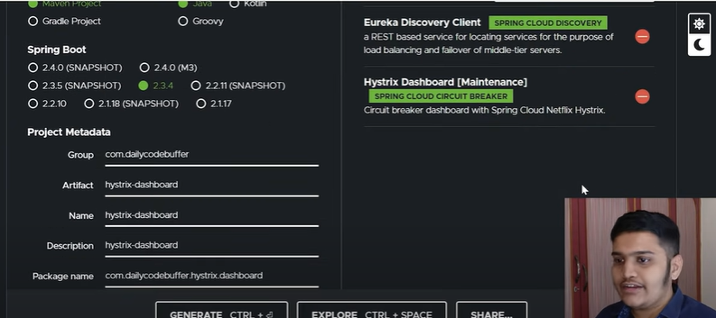

**@EnableHystrixDashBoard** – To give dashboard view of Hystrix stream.  
**@EnableCircuitBreaker** – To enable Circuit breaker implementation

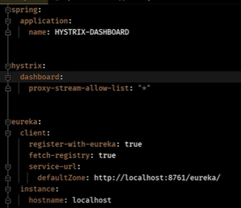

Add API gateway servies :

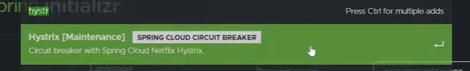

@enableHystrix

Create controller:

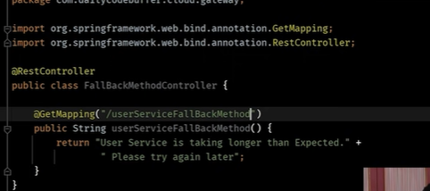

Add application.property

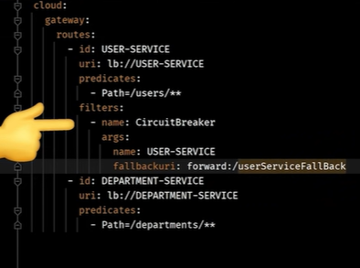

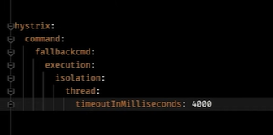

Logger :

ZPIKIN



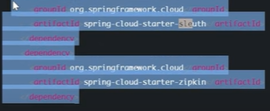

Add dependency in each servies for logger

Install zipkin application check servies in zipkin.

Trace id & span id

Trace id is servies id

Span id use api in servies

Trace id is unquie for servies

Span id different on API.

# Service Discovery and Service Registry in Microservices

Microservices are small, loosely coupled distributed services. Microservices architecture evolved as a solution to the scalability, independently deployable, and innovation challenges with Monolithic Architecture. It provides us to take a big application and break it into efficiently manageable small components with some specified responsibilities. It is considered the building block of modern applications. Before understanding What is Service Discovery let’s understand what is the need for **Service Discovery**in Microservices.

### What’s the Problem/Challenge?

Imagine you are writing microservices. Your company has adopted the microservices architecture you have Address Service, Employee Service, Course Service, Student Service, etc, etc. You have many spring boot applications and all the spring boot application has been deployed into many different servers and you might have thousands of applications. Right now all these applications let’s say Course Service wants to connect to the Address Service, Student Service wants to connect to the Course Service, and wants to get some course-related data then how will these servers communicate with each other? We will simply make a [**REST**](https://www.geeksforgeeks.org/rest-api-introduction/)call and all these servers will communicate with each other using the REST API. But the real challenging part is when a server wants to connect to another server then before this server connects to this server it needs to know the [**IP address**](https://www.geeksforgeeks.org/what-is-an-ip-address/), and it needs to know the [**port number**](https://www.geeksforgeeks.org/difference-between-ip-address-and-port-number/) where this particular application is running in the server.

This is not going to be a simple job to manage the thing where you have thousands and thousands of applications. How you will manage the server IP? How you’ll maintain their port number? Because every server, when you want some data from another server, it needs to connect to them, and in order to connect to them it needs to know the IP and the server address of that and it will be a really critical job to handle all the IP and the server ports where you have thousands of servers where you have split your one application into thousands of different modules and deployed into different servers. Don’t you think managing the **IP** and the server **URL** will be critical? In the case of a [Monolithic Application](https://www.geeksforgeeks.org/monolithic-vs-microservices-architecture/), there we have only one server so we used to remember the server IP and the port but now your monolithic has been split into thousands of applications how’ll be handling that? And for that **Spring Cloud is providing us with Service Discovery and Service Registry to handle this problem.**

### What’s Service Discovery and Service Registry in Microservices?

Suppose we have Service-A & Service-B and we have our Load Balancer placed inside a different server. Now let’s introduce our Discovery Service. Now what this discovery service will do now whenever Service-A and Service-B want to communicate with each other then whenever we are starting our Microservices we’ll be registering them with Discovery Service. And this discovery service right now will know what is the IP and port number of Service-A and what is the IP and port number of Service-B. All detailed information will be there with Discovery Service. Similarly, if we have many different instances of Service-B, all this Service-B which is running in different servers will be registering their information with Discovery Service. So it is one central location where we’ll be managing our host and the port number information inside this particular server. This is basically called registration because all the services whenever they are starting off they are registering themselves with the discovery service and now the discovery service is maintaining all their information inside a particular map or a list or a database. We called it a **Service Registry**.

So, Service Registry is a crucial part of service identification. It’s a database containing the network locations of service instances. A Service Registry must be highly available and up-to-date. Here, inside Service Registry we have 4 different instances of Service-B and they are running in some port number and some IP address. Similarly, for Service-A we have one different instance.

Now Service-A wants to connect to Service-B. Now the load balancer once get the request, it is gonna do a query with the discovery service that, hey, can you tell me what instances are there for Service-B? Now the load balancer finds out that there are this many instances available where Service-B has been deployed. Now Load Balancer is going to dispatch to one of the servers by looking into Service Registry. It can take all four instances of Service-B and whoever has less load then to balance the load, it can send the request to there.

***Note****: Don’t mix up load balancing and service discovery. The Load Balancer job is to do load balancing while the Service Discovery job is to do discovering service info. When we build Microservices and call other microservices, we need service discovery to find the hosts and IP info and if multiple hosts are available then the load balancer helps to pick one and make a call in a load-balanced way.*

### Types of Service Discovery

There are two types of Service Discovery

* Client-Side Service Discovery
* Server-Side Service Discovery

**Point to Remember:**

* **Client-Side Service Discovery Example**: Netflix Eureka, Zookeeper, Consul
* **Server-Side Service Discovery Example**: NGNIX, AWS ELB

# Resilience4J: Circuit Breaker Implementation on Spring Boot

[[](https://medium.com/@pramuditya?source=post_page-----9f8d195a49e0--------------------------------)](https://medium.com/@pramuditya?source=post_page-----9f8d195a49e0--------------------------------)

[[](https://medium.com/bliblidotcom-techblog?source=post_page-----9f8d195a49e0--------------------------------)](https://medium.com/bliblidotcom-techblog?source=post_page-----9f8d195a49e0--------------------------------)

[Pramuditya Ananta Nur](https://medium.com/@pramuditya?source=post_page-----9f8d195a49e0--------------------------------)

·

[Follow](https://medium.com/m/signin?actionUrl=https%3A%2F%2Fmedium.com%2F_%2Fsubscribe%2Fuser%2Fd7e5708a3155&operation=register&redirect=https%3A%2F%2Fmedium.com%2Fbliblidotcom-techblog%2Fresilience4j-circuit-breaker-implementation-on-spring-boot-9f8d195a49e0&user=Pramuditya+Ananta+Nur&userId=d7e5708a3155&source=post_page-d7e5708a3155----9f8d195a49e0---------------------post_header-----------)

Published in

[Blibli.com Tech Blog](https://medium.com/bliblidotcom-techblog?source=post_page-----9f8d195a49e0--------------------------------)

·

7 min read

·

Jul 2, 2021

157

3

*In a microservice architecture, it’s common for a service to call another service. And there is always the possibility that the other service being called is unavailable or unable to respond. So, what can we do when this happens?*

## **Introduction**

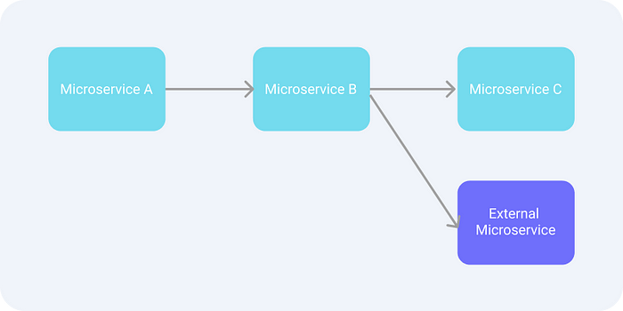

Microservices illustration

Let’s take a look at example cases below.

* When **microservice B** calls **microservice C**and **microservice C** unavailable or unable to respond, **microservice B** may have encountered an error. And if **microservice A** calls **microservice B** which is encountered an error, this causes **microservice A** is just wastingits resources, right?  
  Actually, we can tune or optimize the microservice, ‘cause it’s still within the scope of our workspace.
* When **microservice B** calls the **external microservice** and unfortunately the **external microservice** is down. Actually, **microservice B** is just wasting its resources. This will also definitely affect **microservice B** when called by **microservice A**. In this case, there is nothing to do except wait for a third party to check what’s wrong with their microservice.

From the 2 cases above, we can conclude that when a microservice encounters an error, it will have an impact on other microservices that call it, and will also have a domino effect. Then, what can be done to prevent a domino effect like the cases above? Well, the answer is a **circuit breaker** mechanism.

## **What is Circuit Breaker?**

The concept of a circuit breaker is to prevent calls to microservice when it’s known the call may fail or time out. This is done so that clients don’t waste their valuable resources handling requests that are likely to fail. Using this concept, you can give the server some spare time to recover.

So, how do we know if a request is likely to fail? Yeah, this can be known by recording the results of several previous requests sent to other microservices. For example, 4 out of 5 requests sent failed or timeout, then most likely the next request will also encounter the same thing.

## **Circuit Breaker State**

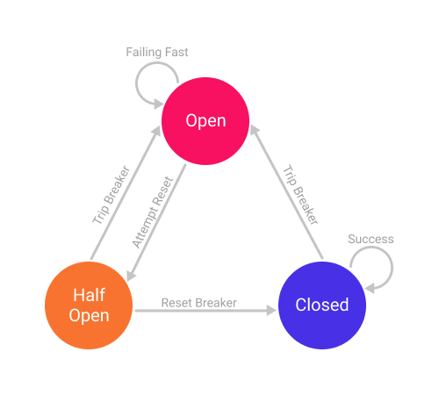

Circuit Breaker State

In the circuit breaker, there are 3 states **Closed**, **Open**, and **Half-Open**.

* **Closed**: when everything is normal. Initially, the circuit breaker is in a **Closed state.**
* **Open:**when a failure occurs above predetermined criteria. In this state, requests to other microservices will not be executed and fail-fast or fallback will be performed if available. When this state has passed a certain time limit, it will automatically or according to certain criteria will be returned to the **Half-Open state.**
* **Half-Open:**several requests will be executed to find out whether the microservices that we are calling are working normally. If successful, the state will be returned to the **Closed** **state**. However, if it still fails it will be returned to the **Open state**.

## **Circuit Breaker Type**

There are 2 types of circuit breaker patterns, **Count-based** and **Time-based.**

* **Count-based**: the circuit breaker switches from a closed state to an open state when the last N requests have failed or timeout.
* **Time-based**: the circuit breaker switches from a closed state to an open state when the last N time unit has failed or timeout.

In both types of circuit breakers, we can determine what the threshold for failure or timeout is. Suppose we specify that the circuit breaker will trip and go to the **Open state** when 50% of the last 20 requests took more than 2s, or for a time-based, we can specify that 50% of the last 60 seconds of requests took more than 5s.

After we know how the circuit breaker works, then we will try to implement it in the spring boot project.

## Prerequisites

One of the libraries that offer a circuit breaker features is [**Resilience4J**](https://resilience4j.readme.io/)**.**So, for the example project, we’ll use this library. First, we create a spring boot project with these required dependencies:

**Implementation**

We will create a simple REST API to start simulating a circuit breaker. This REST API will provide a response with a time delay according to the parameter of the request we sent. For example, if we send a request with a delay of 5 seconds, then it will return a response after 5 seconds. In the other words, we will make the circuit breaker trips to an **Open State** when the response from the request has passed the time unit threshold that we specify.

Pay attention to line 3. An API with a circuit breaker is simply marked using the **@CircuitBreaker**annotation followed by the name of the circuit breaker.

Next, we will configure what conditions will cause the circuit breaker to trip to the **Open State**.

The above configuration will create a shared circuit breaker configuration. It can be used for any circuit breaker instance we want to create. Notice that we created an instance named **example**, which we use when we annotate **@CircuitBreaker** on the REST API.

Let’s look at the following configurations:

* **Sliding-window-type**: we will use a **count-based** circuit breaker type. In this type, the circuit will trip or move to an open state based on each incoming request.
* **Sliding-window-size**: we will use this parameter to record the last N requests to make the circuit breaker trip or open. Here, we will record the last 5 requests.
* **Failure-rate-threshold**: it shows the percentage of the total **sliding-window-size** that fails and will cause the circuit breaker trips to open state. This means, with a configuration of 40%, 2 out of 5 failed requests will cause the circuit breaker trips to open state.
* **Slow-call-rate-threshold**: it shows the percentage of the total **sliding-window-size** that fails which will cause the circuit breaker trips to open state. From the configuration above, it can be seen that 2 out of 5 failed requests will cause the circuit breaker trips to open state.
* **Slow-call-duration-threshold**: is the time taken to indicate the received response exceeds this configuration time will be recorded as an error count.

# Different Ways to Establish Communication Between Spring Microservices

If you are working with a Spring Boot project which involves multiple microservices, You might have felt the need to communicate from microservice m1 to microservice m2. Depending upon business use-cases, this communication can be of synchronous or asynchronous type. Before digging dip further. Let’s understand the use-case first.  There are two microservices:

1. Restaurant-Service: Responsible for maintaining items being served by a restaurant, processing orders, etc.
2. User-Service: Responsible for maintaining user details.

Now suppose a user visits a restaurant’s page, selects some cuisine of his choice and clicks on the “Place Order” button. When this request lands in restaurant-service, the service would want to validate user details before processing this order. But our user details lie under user-service. Hence here comes the need to communicate from restaurant-service to user-service. Synchronous communication of m2 from m1 is like calling an API of m2 directly from m1.

### Synchronous Way

When we talk about **synchronous** communication, there could be two ways:

1. **REST Template**
2. **Feign**

**REST Template**

REST Template is the easiest way to establish synchronous communication from m1 to m2. RestTemplate is a class available under spring.framework.web.client that acts as a synchronous client to perform HTTP requests. In the below example, we have used  *getForEntity method*that accepts complete URL of the user-service that we want to invoke, followed by Data-Object class name which that URL is supposed to return, and a map. If the provided userId is not valid, the API call would throw a custom exception which we are handing on the restaurant-service side.

* Java

|  |
| --- |
| HashMap<String, Long> params = **new** HashMap<>();  params.put("userId", orderDetails.getUserId());  **try** {      ResponseEntity<User> response          = **new** RestTemplate().getForEntity(              "<http://localhost:8080/users/>{userId}",              User.**class**, params);  }  **catch** (Exception ex) {  **throw** **new** InvalidUserIdException(          "User Id " + orderDetails.getUserId()          + " Not Found");  } |

**Feign**

Feign requires additional configuration across both services if you want to go by this way. This approach uses standard Java interfaces. Addition perks of using feign over rest-template is that you don’t get to hard-code your URL here. Eureka Client ID can also be used for server-discovery purposes in order to establish communication.

### Asynchronous Way

One possible **asynchronous** way to establish communication is by using a message broker. Let’s understand the use-case first.

Considering the microservices discussed above, let’s suppose a user has placed his order. Now the order would go under various stages like *Accepted, Preparation-Started, Ready-To-Pick, Delivered*. Assuming all the stages of the order would be updated by the restaurant-service, we want to notify user-service every time the order-status is updated. Now this can be achieved either way but the asynchronous way would be more convenient here.

* Message-Broker: It behaves as an intermediary service between m1 and m2. When m1 has to communicate with m2, m1 would push a message to the broker instead of directly sending it to the m2. Depending on the broker’s type (ActiveMQ and Kafka are two popular message-brokers but they have different approaches of communication), the message will be conveyed to the listener of m2 and action would be taken accordingly. Here m1 would be known as producer while m2 would be known as consumer.

### Why Do We Need Transaction Management?

Let’s understand transactions with the above example, if a user has entered his information the user’s information gets stored in the user\_info table. Now, to book a ticket he does an online payment and due to some reason(system failure) the payment has been canceled so, the ticket is not booked for him. But, the problem is that his information gets stored on the user\_info table. On a large scale, more than thousands of these things happen within a single day. So, it is not good practice to store a single action of the transaction(Here, only user info is stored not the payment info).

To overcome these problems, spring provides transaction management, which uses annotation to handle these issues. In such a scenario, spring stores the user information in temporary memory and then checks for payment information if the payment is successful then it will complete the transaction otherwise it will roll back the transaction and the user information does not gets stored in the database.

@Transactional

**public** Employee addEmployee(Employee employee) **throws** Exception {

        Employee employeeSavedToDB = **this**.employeeRepository.save(employee);

        Address address = **new** Address();

        address.setId(123L);

        address.setAddress("Varanasi");

        address.setEmployee(employee);

        // calling addAddress() method

        // of AddressService class

**this**.addressService.addAddress(address);

**return** employeeSavedToDB;

    }

**What is API Gateway Pattern:**The API Gateway Pattern in some cases stands for “Backend for frontend”. It basically the entry gate for taking entry in any application by an external source. The pattern which is going on in a programmer’s mind while they are making the client’s application. It acts as a medium between the client applications and microservices. For example-Netflix is the most famous example of an API gateway.

**Use of the API Gateway Pattern:**The main responsibility of this pattern is that it routes the request means basically provide a road map for how our request goes, approve or may be canceled, API  composition, and app authentication.

**How API Gateway Handles the Client requests:**

* API requests mostly come from clients who are external and firstly go to API gateway.
* It is the working of API gateway which routes the request to their place.
* The other additive requests i.e. using multiple services and the aggregating result are handled by API gateway.

# Spring Boot Microservices Communication using WebClient with

WebClient is an interface illustrating the main entry point for performing web requests. It is also known as the reactive web client which is introduced in Spring 5. This new client is a reactive, non-blocking solution that works over the HTTP/1.1 protocol. We can also say that it is a replacement for the classic [RestTemplate](https://www.geeksforgeeks.org/spring-resttemplate/). It is a part of spring-webflux library and also offers support for both synchronous and asynchronous operations. The DefaultWebClient class implements this WebClient interface. The basic syntax is given below

# RestTemplate with Example

RestTemplate is a synchronous REST client which performs HTTP requests using a simple template-style API. We can also state that RestTemplate class is a synchronous client and is designed to call REST services. Apart from that, **RestTemplate class plays a major role whenever we talk about Spring Boot Microservices Communication**. The basic syntax of this class is given below

# Difference between Synchronous and Asynchronous Transmission

**Synchronous Transmission:** In Synchronous Transmission, data is sent in form of blocks or frames. This transmission is the full-duplex type. Between sender and receiver, synchronization is compulsory. In Synchronous transmission, There is no gap present between data. It is more efficient and more reliable than asynchronous transmission to transfer a large amount of data.

**Example:**

* Chat Rooms
* Telephonic Conversations
* Video Conferencing   
  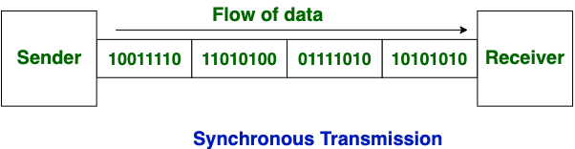

**Asynchronous Transmission:** In Asynchronous Transmission, data is sent in form of byte or character. This transmission is the half-duplex type transmission. In this transmission start bits and stop bits are added with data. It does not require synchronization.

**Example:**

* Email
* Forums
* Letters  
  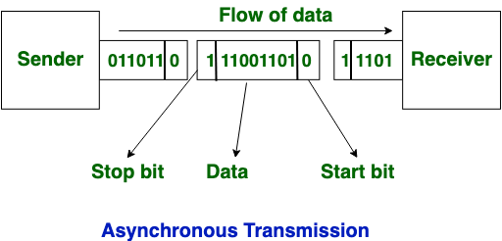

Now, let’s see the difference between [Synchronous Transmission](https://www.geeksforgeeks.org/synchronous-data-transfer-in-computer-organization/) and [Asynchronous Transmission](https://www.geeksforgeeks.org/asynchronous-serial-data-transfer/):

| **S. No.** | **Synchronous Transmission** | **Asynchronous Transmission** |
| --- | --- | --- |
| **1.** | In [Synchronous transmission](https://www.geeksforgeeks.org/synchronous-data-transfer-in-computer-organization/), data is sent in form of blocks or frames. | In [Asynchronous transmission](https://www.geeksforgeeks.org/asynchronous-serial-data-transfer/), data is sent in form of bytes or characters. |
| **2.** | Synchronous transmission is fast. | Asynchronous transmission is slow. |
| **3.** | Synchronous transmission is costly. | Asynchronous transmission is economical. |
| **4.** | In Synchronous transmission, the time interval of transmission is constant. | In Asynchronous transmission, the time interval of transmission is not constant, it is random. |
| **5.** | In this transmission, users have to wait till the transmission is complete before getting a response back from the server. | Here, users do not have to wait for the completion of transmission in order to get a response from the server. |
| **6.** | In Synchronous transmission, there is no gap present between data. | In Asynchronous transmission, there is a gap present between data. |
| **7.** | Efficient use of transmission lines is done in synchronous transmission. | While in Asynchronous transmission, the transmission line remains empty during a gap in character transmission. |
| **8.** | The start and stop bits are not used in transmitting data. | The start and stop bits are used in transmitting data that imposes extra overhead. |
| **9.** | Synchronous transmission needs precisely synchronized clocks for the information of new bytes. | Asynchronous transmission does not need synchronized clocks as parity bit is used in this transmission for information of new bytes. |
| **10.** | Errors are detected and corrected in real time. | Errors are detected and corrected when the data is received. |
| **11.** | Low latency due to real-time communication. | High latency due to processing time and waiting for data to become available. |

## 1. Zipkin

Zipkin was originally developed at Twitter, based on a concept of a Google paper that described Google’s internally-built distributed app debugger – [dapper](https://research.google/pubs/pub36356/). It manages both the collection and lookup of this data. To use Zipkin, applications are instrumented to report timing data to it.

If you are troubleshooting latency problems or errors in an ecosystem, you can filter or sort all traces based on the application, length of trace, annotation, or timestamp. By analyzing these traces, you can decide which components are not performing as per expectations, and you can fix them.

Internally it has 4 modules –

1. **Collector** – Once any component sends the trace data, it arrives to Zipkin collector daemon. Here the trace data is validated, stored, and indexed for lookups by the Zipkin collector.
2. **Storage** – This module store and index the lookup data in backend. [Cassandra](https://cassandra.apache.org/_/index.html), [ElasticSearch](https://www.elastic.co/" \t "_blank) and [MySQL](https://howtodoinjava.com/mysql/how-to-installuninstallexecute-mysql-as-windows-service/) are supported.
3. **Search** – This module provides a simple JSON API for finding and retrieving traces stored in backend. The primary consumer of this API is the Web UI.
4. **Web UI** – A very nice UI interface for viewing traces.

### 1.1. Installing Zipkin

Detailed installation steps can be found for different operating systems including the Docker image on the quickstart page. For windows installation, just download the latest Zipkin server from the maven repository and run the executable jar file using the below command.

Start Zipkin on Windows

java -jar zipkin-server-1.30.3-exec.jar

Once Zipkin is started, we can see the Web UI at <http://localhost:9411/zipkin/>.

The above command will **start the Zipkin server with the default configuration**. For advanced configuration, we can configure many other things like storage, collector listeners etc.

To **install Zipkin in the**spring boot application, we need to add [Zipkin starter dependency](https://mvnrepository.com/artifact/org.springframework.cloud/spring-cloud-starter-zipkin).

pom.xml

**<dependency>**

**<groupId>**org.springframework.cloud**</groupId>**

**<artifactId>**spring-cloud-starter-zipkin**</artifactId>**

**</dependency>**

## 2. Sleuth

[Sleuth](https://cloud.spring.io/spring-cloud-sleuth/) is another tool from the Spring cloud family. It is **used to generate the trace id, span id and add this information to the service calls in the headers and MDC**, so that It can be used by tools like Zipkin and [ELK](https://howtodoinjava.com/spring-cloud/elk-stack-tutorial-example/) etc. to store, index and process log files.

**What is OpenFeign?**

OpenFeign is a declarative REST client. It makes writing web service clients easier, just create an interface and add annotations on the interface.

Annotation used

enableeurekaclient

enableconfigserver

loadbalacer

enablehyttrsisdashboard

enablecircultbraker

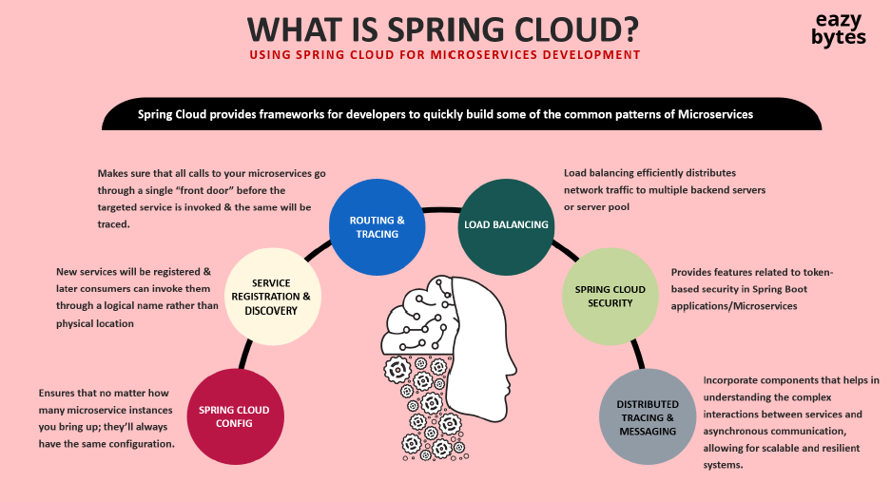

Config

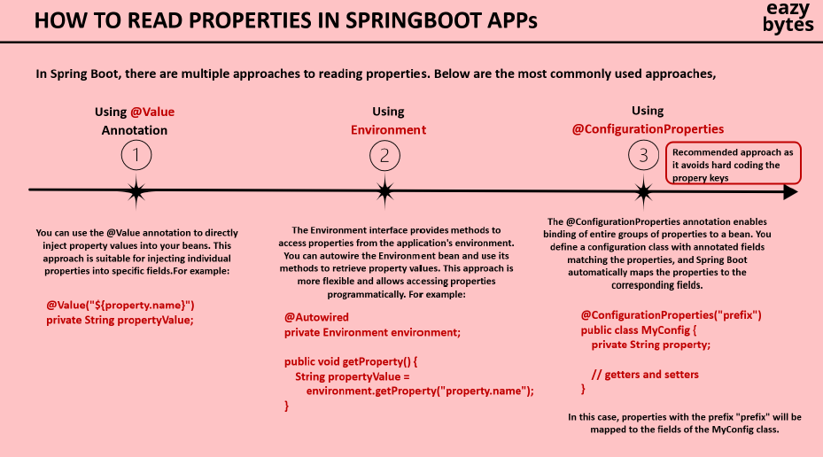

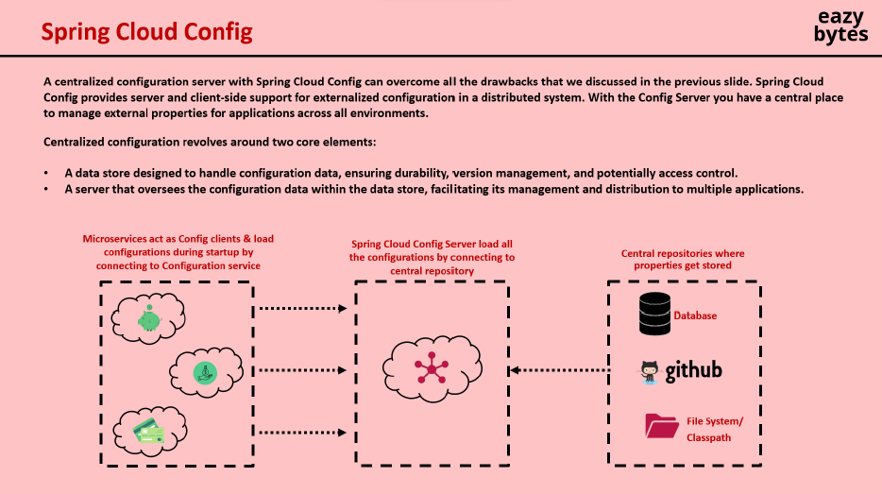

<dependency>

<groupId>org.springframework.cloud</groupId>

<artifactId>spring-cloud-config-server</artifactId>

</dependency>

Annotation

@SpringBootApplication

@EnableConfigServer

Yml file

server:

port: 8888

spring:

cloud:

config:

server:

git:

uri: https://github.com/your-repo/config-repo

default-label: master

clone-on-start: true

other servies add

<dependencies>

<dependency>

<groupId>org.springframework.cloud</groupId>

<artifactId>spring-cloud-starter-config</artifactId>

</dependency>

</dependencies>

Yml file

spring:

application:

name: my-client-service

config:

import: "optional:configserver:http://localhost:8071/"

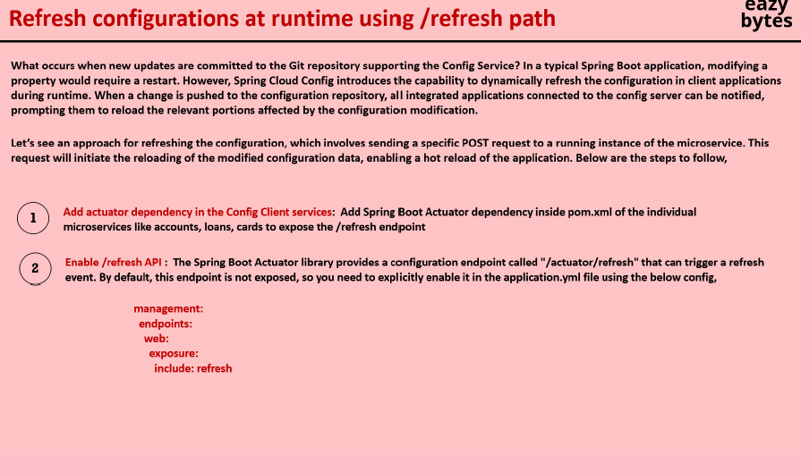

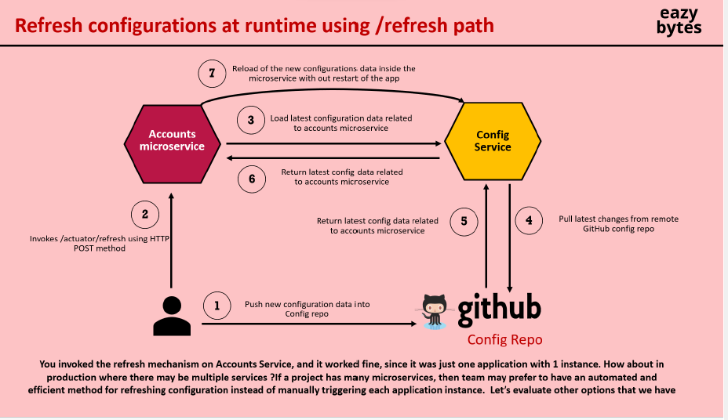

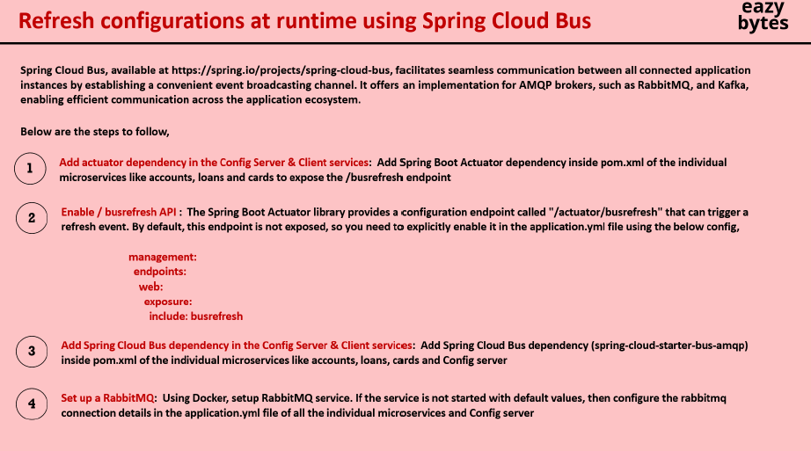

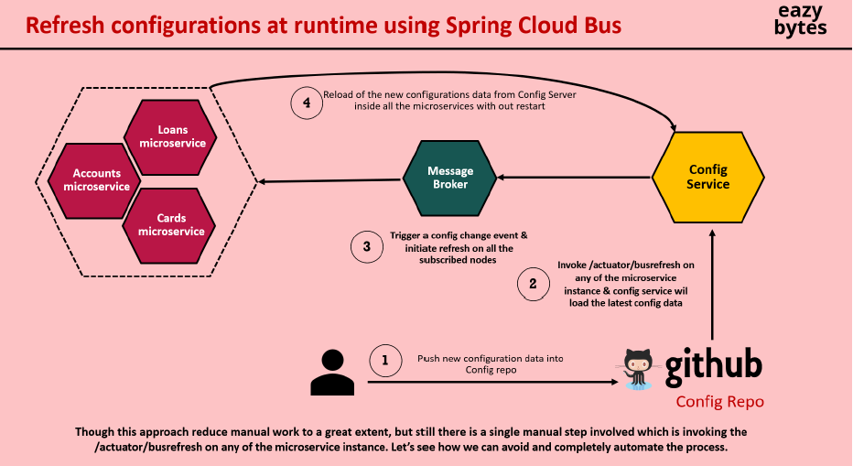

Add all servies & config server

<dependency>

<groupId>org.springframework.cloud</groupId>

<artifactId>spring-cloud-starter-bus-amqp</artifactId>

</dependency>

Add application property

rabbitmq:

host: "localhost"

port: 5672

username: "guest"

password: "guest"

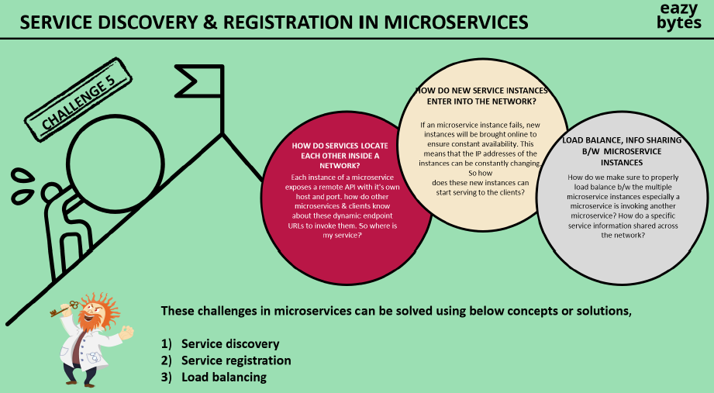

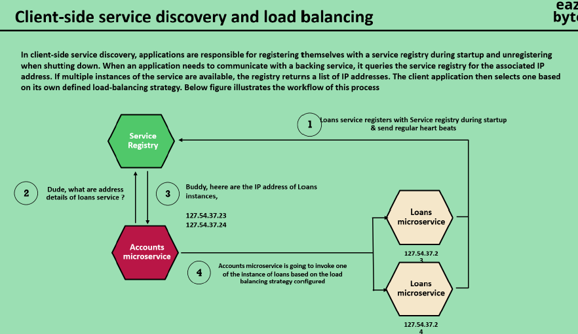

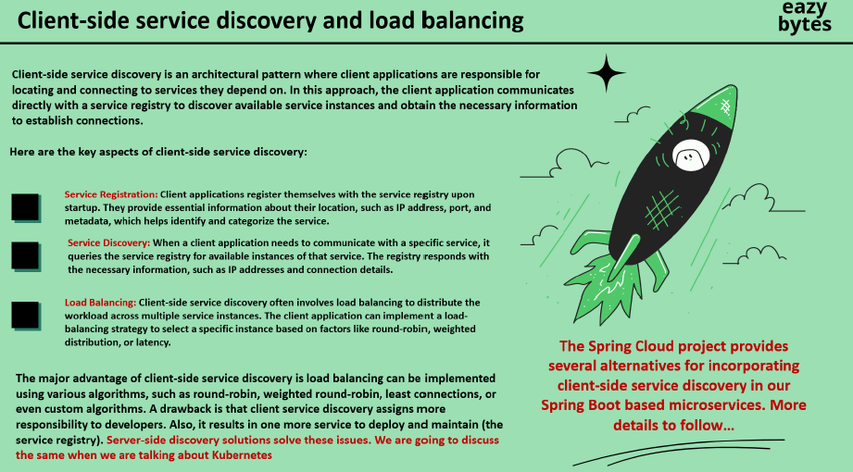

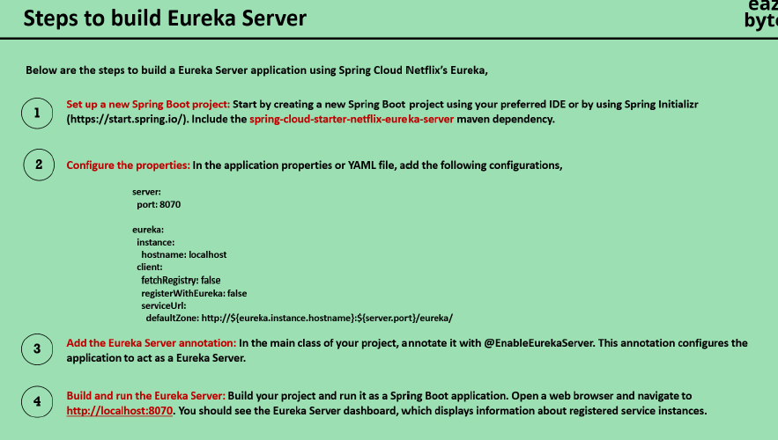

* **RestTemplate**: Best for synchronous, simple requests in older Spring applications. However, it is deprecated in favor of WebClient for new projects.
* **WebClient**: A modern, flexible client that supports both **blocking and non-blocking** operations. It’s suitable for both synchronous and asynchronous applications, especially those requiring high concurrency and scalability.
* **FeignClient**: A **declarative HTTP client** that integrates well with **Spring Cloud** for microservice-to-microservice communication, making it easy to call REST services without manual configuration of the HTTP client.

In most modern microservices-based Spring applications, you'll likely use **FeignClient** for service-to-service communication and **WebClient** for advanced use cases requiring asynchronous, non-blocking communication.

**Configure WebClient**

Create a configuration class to configure WebClient:

java

Copy code

import org.springframework.context.annotation.Bean;

import org.springframework.context.annotation.Configuration;

import org.springframework.web.reactive.function.client.WebClient;

@Configuration

public class WebClientConfig {

@Bean

public WebClient.Builder webClientBuilder() {

return WebClient.builder();

}

}

**4. Create a Service to Use WebClient**

Here, you can create a service that will use the WebClient to send a POST request.

java

Copy code

import org.springframework.beans.factory.annotation.Autowired;

import org.springframework.stereotype.Service;

import org.springframework.web.reactive.function.client.WebClient;

import reactor.core.publisher.Mono;

@Service

public class UserService {

@Autowired

private WebClient.Builder webClientBuilder;

public Mono<String> createUser(User user) {

return webClientBuilder.build()

.post()

.uri("http://localhost:8081/api/users") // URL of Service B's POST endpoint

.bodyValue(user) // Sending the User object in the request body

.retrieve() // Initiates the request

.bodyToMono(String.class); // Expecting a String response

}

}

<dependency>

<groupId>org.springframework.cloud</groupId>

<artifactId>spring-cloud-starter-openfeign</artifactId>

</dependency>

**Service A - Enable Feign in Spring Boot:**

java

Copy code

import org.springframework.cloud.openfeign.EnableFeignClients;

import org.springframework.boot.SpringApplication;

import org.springframework.boot.autoconfigure.SpringBootApplication;

@SpringBootApplication

@EnableFeignClients

public class ServiceAApplication {

public static void main(String[] args) {

SpringApplication.run(ServiceAApplication.class, args);

}

}

**Service A - FeignClient to communicate with Service B:**

java

Copy code

import org.springframework.cloud.openfeign.FeignClient;

import org.springframework.web.bind.annotation.GetMapping;

@FeignClient(name = "serviceBClient", url = "http://localhost:8081")

public interface ServiceBClient {

@GetMapping("/service-b-endpoint")

String getServiceBResponse();

}

import org.springframework.beans.factory.annotation.Autowired;  
import org.springframework.stereotype.Service;  
import org.springframework.web.client.RestTemplate;  
  
@Service  
public class RestTemplateService {  
  
 @Autowired  
 private RestTemplate restTemplate;  
  
 public String getPost(int id) {  
 String url = "https://jsonplaceholder.typicode.com/posts/" + id;  
 return restTemplate.getForObject(url, String.class);  
 }  
}

**POST Request**

For a POST request, you can use the postForObject or postForEntity methods. Here’s how to send a JSON payload:

import org.springframework.beans.factory.annotation.Autowired;  
import org.springframework.stereotype.Service;  
import org.springframework.web.client.RestTemplate;  
  
import java.util.HashMap;  
import java.util.Map;  
  
@Service  
public class RestTemplateService {  
  
 @Autowired  
 private RestTemplate restTemplate;  
  
 public String createPost() {  
 String url = "https://jsonplaceholder.typicode.com/posts";  
   
 Map<String, String> request = new HashMap<>();  
 request.put("title", "foo");  
 request.put("body", "bar");  
 request.put("userId", "1");  
   
 return restTemplate.postForObject(url, request, String.class);  
 }  
}

**PUT Request**

For updating resources, you can use the put method:

import org.springframework.beans.factory.annotation.Autowired;  
import org.springframework.stereotype.Service;  
import org.springframework.web.client.RestTemplate;  
  
import java.util.HashMap;  
import java.util.Map;  
  
@Service  
public class RestTemplateService {  
  
 @Autowired  
 private RestTemplate restTemplate;  
  
 public void updatePost(int id) {  
 String url = "https://jsonplaceholder.typicode.com/posts/" + id;  
   
 Map<String, String> request = new HashMap<>();  
 request.put("title", "updated title");  
 request.put("body", "updated body");  
   
 restTemplate.put(url, request);  
 }  
}

**DELETE Request**

To delete a resource, use the delete method:

import org.springframework.beans.factory.annotation.Autowired;  
import org.springframework.stereotype.Service;  
import org.springframework.web.client.RestTemplate;  
  
@Service  
public class RestTemplateService {  
  
 @Autowired  
 private RestTemplate restTemplate;  
  
 public void deletePost(int id) {  
 String url = "https://jsonplaceholder.typicode.com/posts/" + id;  
 restTemplate.delete(url);

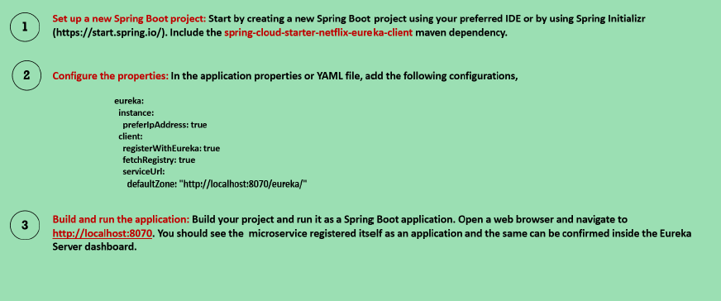

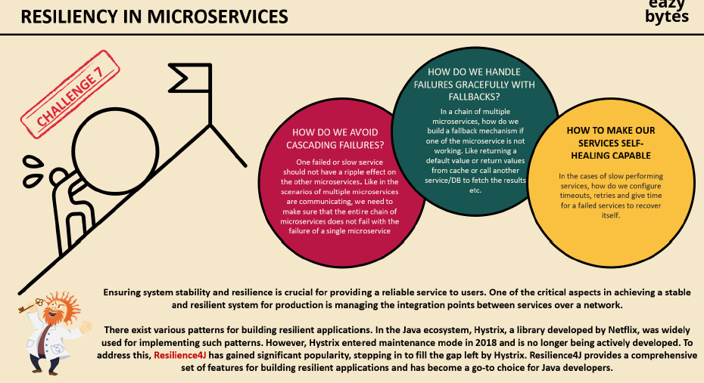

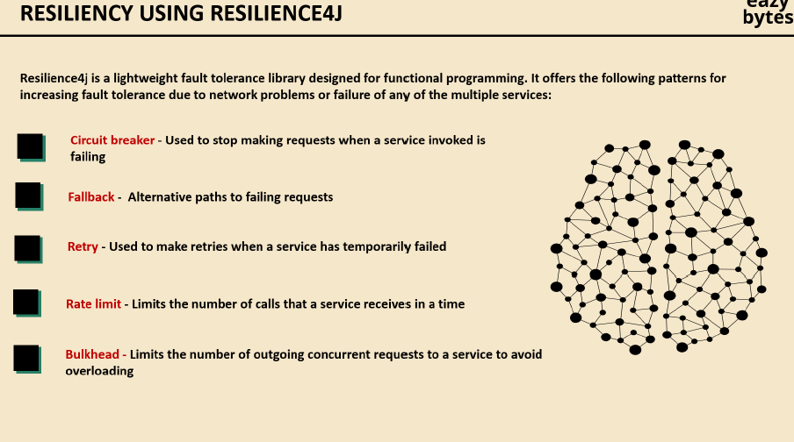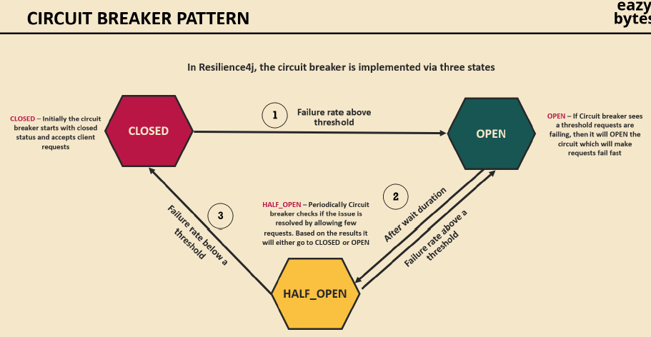

resilience4j.circuitbreaker:

configs:

default:

slidingWindowSize: 10

permittedNumberOfCallsInHalfOpenState: 2

failureRateThreshold: 50

waitDurationInOpenState: 10000

**1. slidingWindowSize: 10**

* **Explanation**: The sliding window is a rolling window that tracks the number of calls used to calculate the failure rate. The slidingWindowSize specifies the number of calls (successful or failed) that the circuit breaker will observe. In this case, the circuit breaker looks at the last 10 calls to decide whether to transition between states (CLOSED, OPEN, HALF-OPEN).

**2. permittedNumberOfCallsInHalfOpenState: 2**

* **Explanation**: In the HALF-OPEN state, the circuit breaker allows a limited number of calls to go through in order to test whether the system has recovered. Here, 2 calls will be permitted while the breaker is in HALF-OPEN. If these calls are successful, the breaker will transition back to CLOSED (normal operation).

**3. failureRateThreshold: 50**

* **Explanation**: The failure rate threshold defines when the circuit breaker will transition from CLOSED to OPEN (failures prevent calls). In this case, if 50% or more of the observed calls (from the sliding window) fail, the circuit breaker opens, stopping further calls until the breaker moves to HALF-OPEN or CLOSED again.

**4. waitDurationInOpenState: 10000**

* **Explanation**: This is the time (in milliseconds) the circuit breaker will remain in the OPEN state before transitioning to HALF-OPEN. In this case, it waits for 10 seconds (10,000 milliseconds). During this period, no requests will be allowed through.

resilience4j.circuitbreaker:

instances:

myServiceCircuitBreaker:

registerHealthIndicator: true

slidingWindowSize: 10

minimumNumberOfCalls: 5

failureRateThreshold: 50

waitDurationInOpenState: 10000 # 10 seconds

permittedNumberOfCallsInHalfOpenState: 3

automaticTransitionFromOpenToHalfOpenEnabled: true

slidingWindowType: COUNT\_BASED

Key configuration parameters:

* **failureRateThreshold**: The percentage of failures that trigger the circuit breaker to open (e.g., 50%).
* **waitDurationInOpenState**: The time the circuit breaker stays open before transitioning to the half-open state (in milliseconds).
* **slidingWindowSize**: The number of calls to keep track of when determining the failure rate.
* **permittedNumberOfCallsInHalfOpenState**: The number of calls allowed when the circuit breaker is half-open, before transitioning to closed or open based on their success/failure.
* **automaticTransitionFromOpenToHalfOpenEnabled**: Automatically transitions the circuit breaker from open to half-open after the wait duration has passed

Add in Gateway

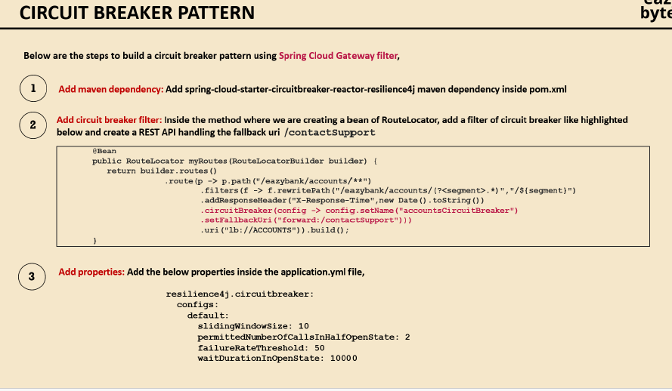

# Gateway Configuration

spring.cloud.gateway.routes[0].id=serviceA

spring.cloud.gateway.routes[0].uri=http://localhost:8081

spring.cloud.gateway.routes[0].predicates[0]=Path=/service-a/\*\*

spring.cloud.gateway.routes[0].filters[0]=CircuitBreaker=name=default,fallbackUri=forward:/fallback

# Circuit Breaker Configuration

spring.cloud.circuitbreaker.resilience4j.instances.default.sliding-window-size=10

spring.cloud.circuitbreaker.resilience4j.instances.default.failure-rate-threshold=50

spring.cloud.circuitbreaker.resilience4j.instances.default.wait-duration-in-open-state=10000

spring.cloud.circuitbreaker.resilience4j.instances.default.permitted-number-of-calls-in-half-open-state=3

Add in servies

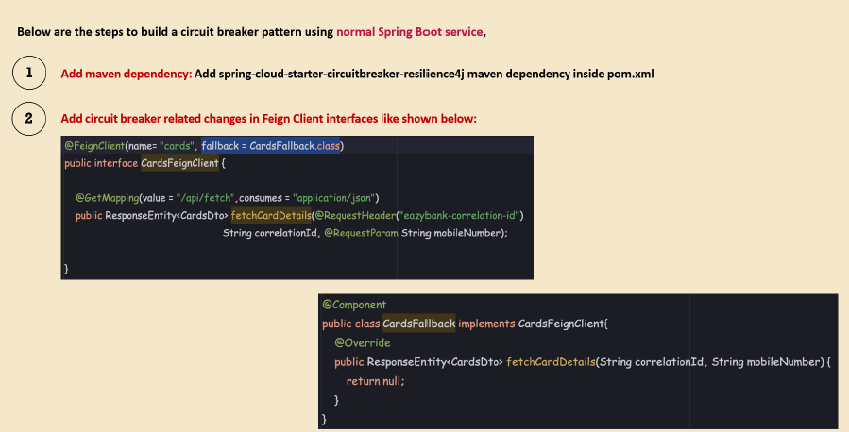

Retry

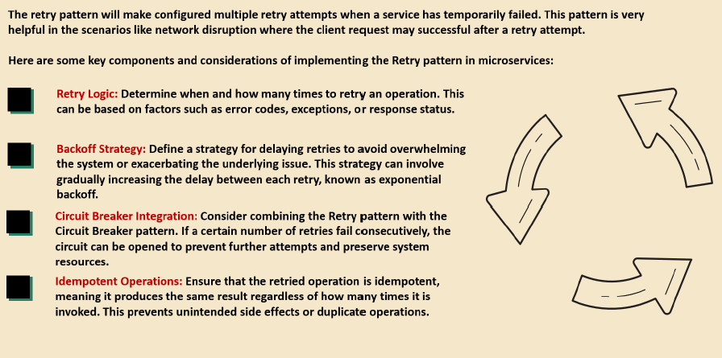

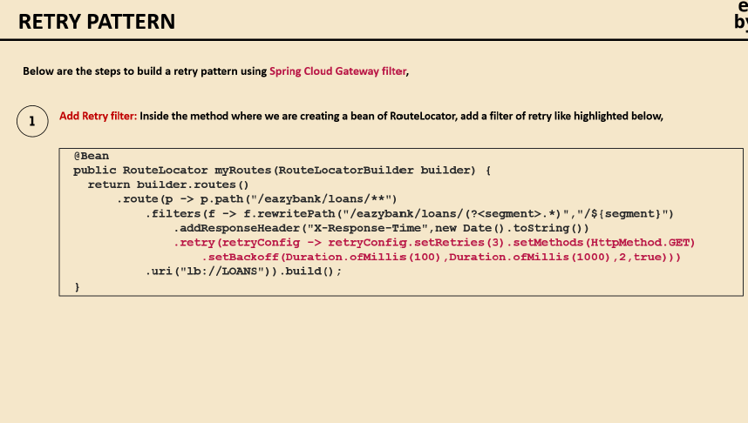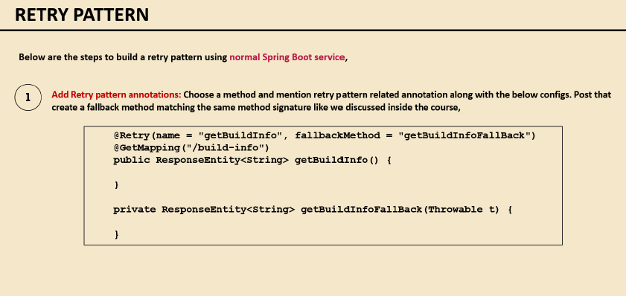

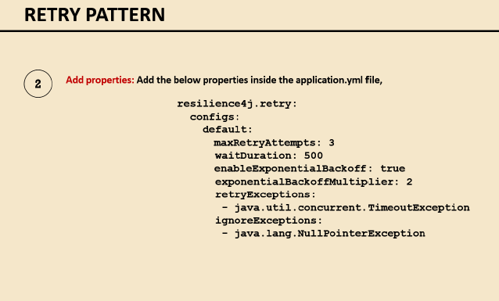

The configuration you’ve provided appears to be for resilience4j-retry, which is a library that allows for retrying failed operations. Below is a breakdown of the configuration parameters:

**Configuration Explanation:**

1. **maxAttempts: 3**:
   * This sets the maximum number of retry attempts. In this case, the operation will be attempted **up to 3 times** before giving up.
2. **waitDuration: 500**:
   * This specifies the wait duration between each retry attempt, defined in milliseconds. In this case, it is set to **500 milliseconds**.
3. **enableExponentialBackoff: true**:
   * When set to true, this enables **exponential backoff**, which increases the wait time between each retry attempt exponentially.
4. **exponentialBackoffMultiplier: 2**:
   * This defines the **multiplier** used when exponential backoff is enabled. Here, the wait time doubles with each retry.
     + For example, with waitDuration set to 500 milliseconds, the first retry will wait 500 ms, the second retry will wait 1000 ms (500 \* 2), and so on.
5. **ignoreExceptions**:
   * A list of exceptions that should **not trigger a retry**. In this case, **java.lang.NullPointerException** will be ignored, meaning no retries will be made for this exception.
6. **retryExceptions**:
   * A list of exceptions that **should trigger a retry**. Here, **java.util.concurrent.TimeoutException** will cause a retry attempt.

resilience4j.ratelimiter:

configs:

default:

timeoutDuration: 1000

limitRefreshPeriod: 5000

limitForPeriod: 1

timeoutDuration: 1000:

This specifies the maximum time (in milliseconds) to wait for a permission to perform an operation. In this case, the limit is set to 1000 milliseconds (1 second). If no permission is available within this time, the operation will fail.

limitRefreshPeriod: 5000:

This defines the interval (in milliseconds) at which the rate limiter's permissions are refreshed. Here, it’s set to 5000 milliseconds (5 seconds), meaning the rate limiter will refresh permissions every 5 seconds.

limitForPeriod: 1:

This sets the maximum number of calls allowed during each limitRefreshPeriod. In this case, it’s set to 1, meaning only 1 operation is allowed within each refresh period (i.e., every 5 seconds).

**Steps to Implement the Retry Pattern**

**Step 1: Add Dependencies**

In your pom.xml, include the required dependencies for **Resilience4j** and Spring Boot.

xml

Copy code

<dependency>

<groupId>io.github.resilience4j</groupId>

<artifactId>resilience4j-spring-boot2</artifactId>

<version>1.7.0</version>

</dependency>

<dependency>

<groupId>io.github.resilience4j</groupId>

<artifactId>resilience4j-retry</artifactId>

</dependency>

<dependency>

<groupId>org.springframework.boot</groupId>

<artifactId>spring-boot-starter-aop</artifactId>

</dependency>

For Gradle:

gradle

Copy code

implementation 'io.github.resilience4j:resilience4j-spring-boot2:1.7.0'

implementation 'io.github.resilience4j:resilience4j-retry'

implementation 'org.springframework.boot:spring-boot-starter-aop'

**Step 2: Apply Retry Mechanism in the Service Layer**

Let’s assume you have a service that communicates with another service via a **Feign client** or **RestTemplate**. You can apply the retry mechanism to automatically retry failed calls.

java

Copy code

import io.github.resilience4j.retry.annotation.Retry;

import org.springframework.stereotype.Service;

@Service

public class MyService {

@Retry(name = "myServiceRetry", fallbackMethod = "fallbackMethod")

public String callExternalService() {

// Simulate a call to an external service (e.g., another microservice)

// This could be a FeignClient, RestTemplate, or WebClient call.

return externalServiceClient.getData();

}

// Fallback method to be called when retries are exhausted

public String fallbackMethod(Exception e) {

return "Fallback response: External service is unavailable";

}

}

* **@Retry(name = "myServiceRetry", fallbackMethod = "fallbackMethod")**: This annotation enables retry functionality for the callExternalService method. You specify a name for the retry configuration (more on this in Step 3) and provide a fallback method to handle failures after retries are exhausted.
* **fallbackMethod(Exception e)**: This is the fallback method that will be executed if all retry attempts fail.

**Step 3: Configure Retry in application.yml**

**# Gateway Configuration with Circuit Breaker, Retry, and Fallback**

**spring.cloud.gateway.routes[0].id=serviceA**

**spring.cloud.gateway.routes[0].uri=http://localhost:8081**

**spring.cloud.gateway.routes[0].predicates[0]=Path=/service-a/\*\***

**spring.cloud.gateway.routes[0].filters[0]=CircuitBreaker=name=default,fallbackUri=forward:/fallback**

**spring.cloud.gateway.routes[0].filters[1]=Retry=retries=3,statuses=500,methods=GET,POST**

**# Retry Configuration**

**spring.cloud.gateway.retry.retries=3**

**spring.cloud.gateway.retry.statuses=500**

**spring.cloud.gateway.retry.methods=GET,POST**

**# Circuit Breaker Configuration**

**spring.cloud.circuitbreaker.resilience4j.instances.default.sliding-window-size=10**

**spring.cloud.circuitbreaker.resilience4j.instances.default.failure-rate-threshold=50**

**spring.cloud.circuitbreaker.resilience4j.instances.default.wait-duration-in-open-state=10000**

**spring.cloud.circuitbreaker.resilience4j.instances.default.permitted-number-of-calls-in-half-open-state=3**

You can fine-tune the retry behavior in the application.yml or application.properties file, such as the number of retry attempts, delay between retries, etc.

**Step 4: Applying Retry in Feign Client (Optional)**

If you're using Feign for making HTTP calls, Resilience4j can be applied at the **FeignClient** level as well. You can annotate the Feign client method with @Retry.

Example using Feign Client:

java

Copy code

@FeignClient(name = "service-b", url = "http://service-b.com", fallback = ServiceBFallback.class)

public interface ServiceBClient {

@GetMapping("/api/resource")

@Retry(name = "serviceBRetry", fallbackMethod = "fallbackResponse")

String getResourceFromServiceB();

}

**Step 5: Monitoring with Actuator (Optional)**

To monitor the retry attempts and configurations using Spring Boot Actuator, add the spring-boot-starter-actuator dependency.

xml

Copy code

<dependency>

<groupId>org.springframework.boot</groupId>

<artifactId>spring-boot-starter-actuator</artifactId>

</dependency>

Expose all endpoints in your **application.yml**:

yaml

Copy code

management:

endpoints:

web:

exposure:

include: "\*"

You can now monitor retry metrics via the /actuator/metrics/resilience4j.retry.calls endpoint.

**How the Retry Pattern Works**

1. **First Call**: When callExternalService() is called, it attempts to invoke the external service.
2. **Transient Failure**: If the external service fails (e.g., due to a network issue or a timeout), the retry mechanism will automatically retry the call up to the configured number of times (maxAttempts).
3. **Waiting Between Attempts**: Between each retry attempt, the system will wait for the specified waitDuration.
4. **Success within Retries**: If the external service recovers before the maximum number of retries, the call will succeed, and the result will be returned.
5. **Fallback on Exhaustion**: If all retry attempts are exhausted and the service is still unavailable, the **fallback method** is executed, and a default response is returned.

**When to Use the Retry Pattern**

* **Transient Failures**: Use this pattern to handle temporary issues such as network glitches, timeouts, or intermittent failures in external systems.
* **External APIs**: It is common when making HTTP calls to other services, databases, or third-party APIs.
* **Microservices Communication**: In a distributed microservices architecture, where communication across services is crucial, retries help ensure more robust inter-service communication.

**When Not to Use It**

* **Persistent Failures**: If the failure is not temporary (e.g., a service is permanently down or misconfigured), retries will only add unnecessary load.
* **Limited Resources**: Be cautious when using retries with limited resources (like database connections or CPU), as repeated retries can overwhelm the system.

**Summary**

The **Retry Pattern** improves the resiliency of microservices by automatically retrying failed operations due to temporary issues. In Spring Boot, you can implement it easily using **Resilience4j** and configure the number of attempts, wait time, and conditions under which retries should be made.

Key components:

* **Resilience4j**: A lightweight library for applying the retry pattern in Spring Boot.
* **Spring Retry**: An alternative to Resilience4j for older projects, but Resilience4j is recommended.
* **Fallback**: Provides a default behavior when retries are exhausted, ensuring that the service does not fail permanently.

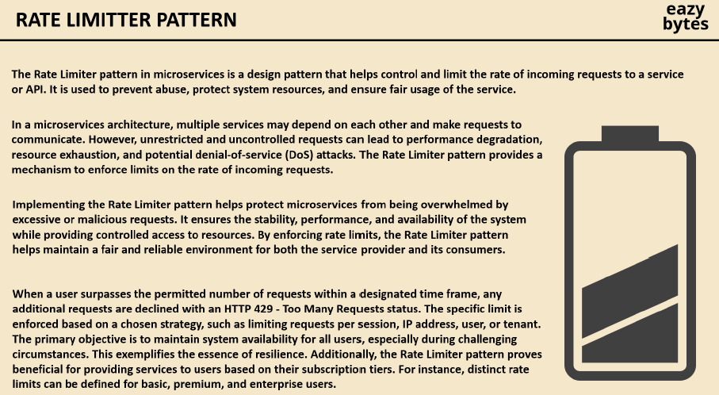

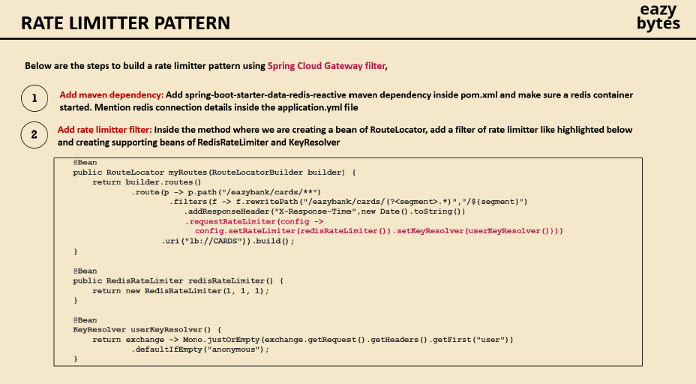

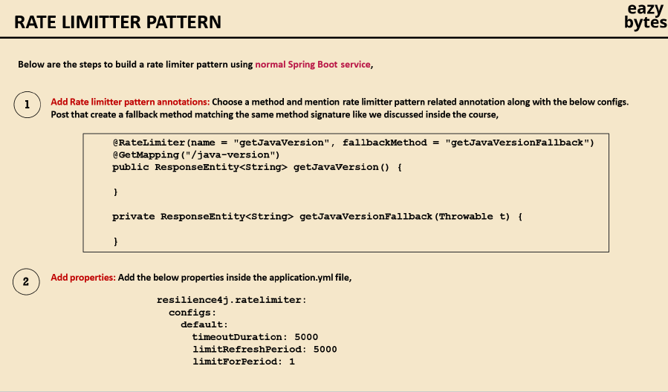

**Add Dependencies**

First, you need to add the required dependencies to your pom.xml file. You will need the Spring Cloud Gateway and Spring Boot Redis dependencies.

xml

Copy code

<dependency>

<groupId>org.springframework.cloud</groupId>

<artifactId>spring-cloud-starter-gateway</artifactId>

</dependency>

<dependency>

<groupId>org.springframework.boot</groupId>

<artifactId>spring-boot-starter-data-redis-reactive</artifactId>

</dependency>

<dependency>

<groupId>org.springframework.cloud</groupId>

<artifactId>spring-cloud-starter-circuitbreaker-resilience4j</artifactId>

</dependency>

Make sure that the Redis service is running and accessible by your application.

**2. Set Up Redis**

Ensure you have Redis running locally or on a remote server. If you don’t have Redis installed, you can download and install it from here, or you can use Docker to spin up a Redis container:

bash

Copy code

docker run -d -p 6379:6379 redis

**3. Configure Rate Limiting in application.properties**

Now, let's configure the rate limiting in your application.properties file. This example sets the maximum allowed requests to 5 per second per user (identified by an API key or IP address).

properties

Copy code

# Gateway Configuration with Rate Limiter and Circuit Breaker

spring.cloud.gateway.routes[0].id=serviceA

spring.cloud.gateway.routes[0].uri=http://localhost:8081

spring.cloud.gateway.routes[0].predicates[0]=Path=/service-a/\*\*

spring.cloud.gateway.routes[0].filters[0]=CircuitBreaker=name=default,fallbackUri=forward:/fallback

spring.cloud.gateway.routes[0].filters[1]=Retry=retries=3,statuses=500,methods=GET,POST

spring.cloud.gateway.routes[0].filters[2]=RequestRateLimiter=redis-rate-limiter

# Rate Limiter Configuration

spring.cloud.gateway.redis-rate-limiter.replenish-rate=5 # Allow 5 requests per second

spring.cloud.gateway.redis-rate-limiter.burst-capacity=10 # Allow a burst of up to 10 requests

spring.redis.host=localhost

spring.redis.port=6379

* replenish-rate: Defines how many tokens are added to the bucket per second (in this case, 5 requests per second).
* burst-capacity: Defines the maximum number of requests that can be made in a short burst (in this case, 10 requests).

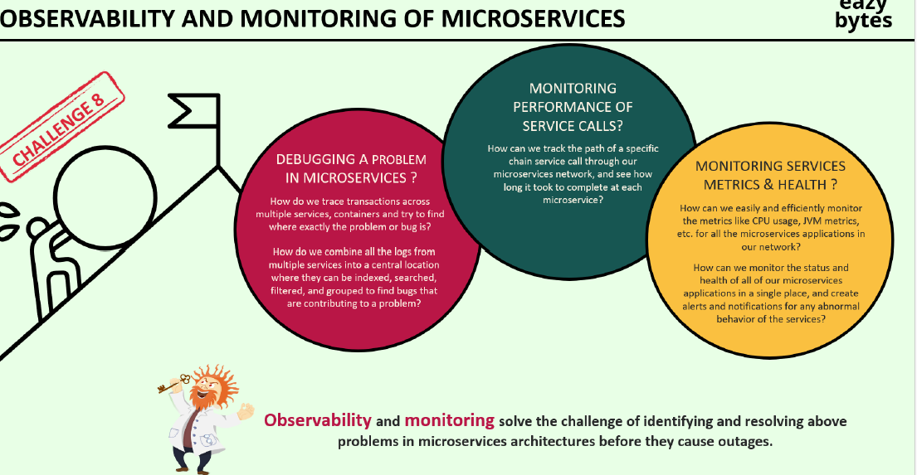

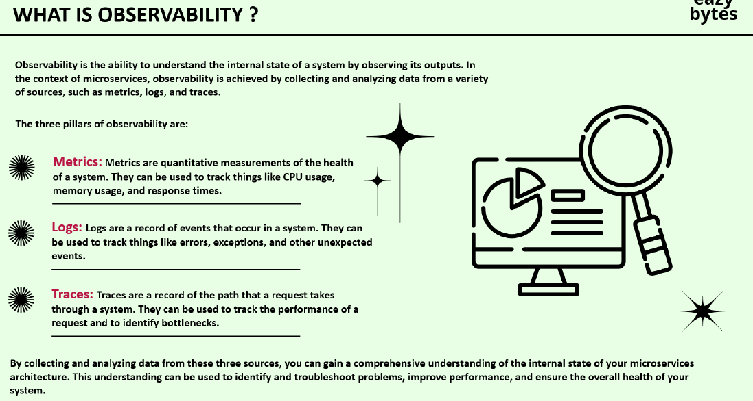

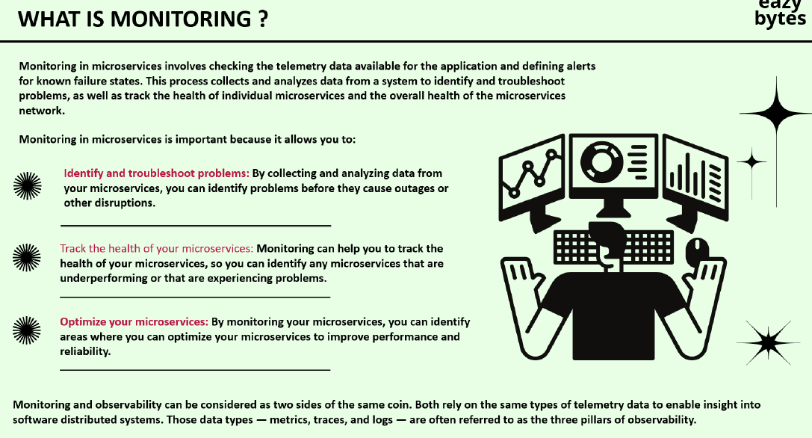

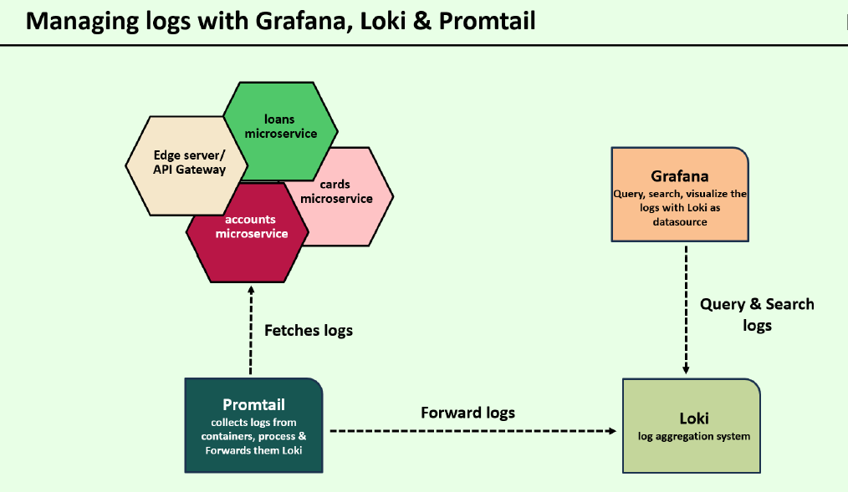

<dependency>

<groupId>org.springframework.boot</groupId>

<artifactId>spring-boot-starter-actuator</artifactId>

</dependency>

<dependency>

<groupId>io.opentelemetry.javaagent</groupId>

<artifactId>opentelemetry-javaagent</artifactId>

<version>${otelVersion}</version>

<scope>runtime</scope>

</dependency>

<dependency>

<groupId>io.micrometer</groupId>

<artifactId>micrometer-registry-prometheus</artifactId>

</dependency>

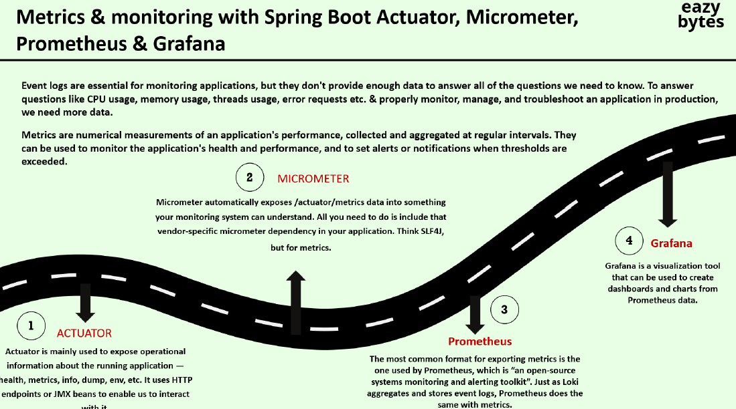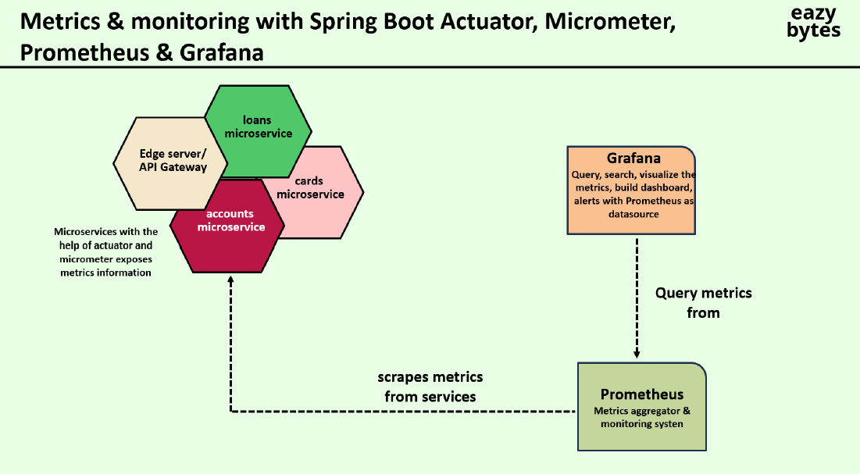

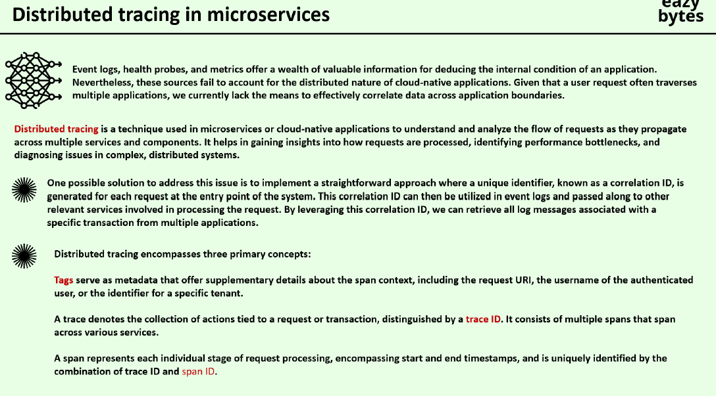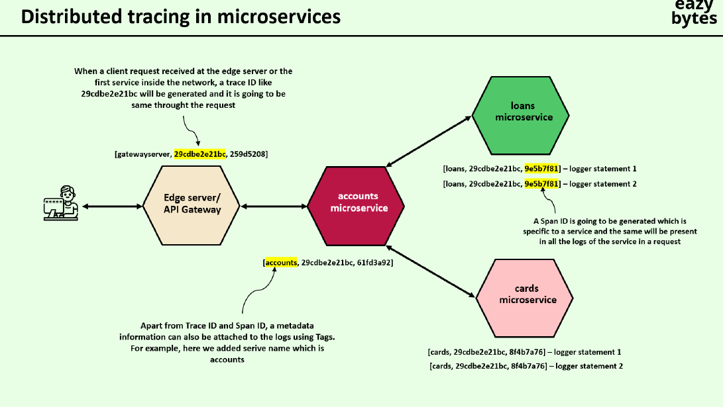

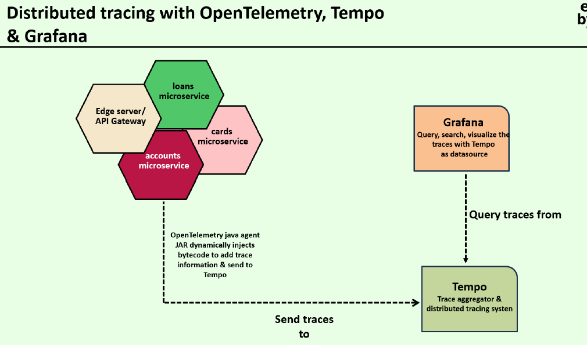

**Redis cache**

<dependency> <groupId>org.springframework.boot</groupId> <artifactId>spring-boot-starter-data-redis</artifactId> </dependency>

spring:

cache:

type: redis

redis:

host: localhost

port: 6379

password: yourPassword # Optional

import org.springframework.boot.SpringApplication;

import org.springframework.boot.autoconfigure.SpringBootApplication;

import org.springframework.cache.annotation.EnableCaching;

@SpringBootApplication

@EnableCaching

public class RedisCacheApplication {

public static void main(String[] args) {

SpringApplication.run(RedisCacheApplication.class, args);

}

}

4. Use Cacheable Annotations

To cache the result of a method, you can use the @Cacheable annotation. This will store the result in Redis, and subsequent calls will use the cached result.

java

Copy code

import org.springframework.cache.annotation.Cacheable;

import org.springframework.stereotype.Service;

@Service

public class UserService {

@Cacheable(value = "users", key = "#userId")

public User getUserById(String userId) {

// Simulate a slow method (e.g., a database call)

simulateSlowService();

return new User(userId, "John Doe");

}

private void simulateSlowService() {

try {

Thread.sleep(3000L); // 3 seconds delay

} catch (InterruptedException e) {

throw new IllegalStateException(e);

}

}

}

In this example, the getUserById() method caches the result under the "users" cache. When the method is called again with the same userId, the cached value will be returned instead of executing the method again.

5. Clear or Update the Cache

To evict or update a cache when a method is called, you can use @CacheEvict or @CachePut.

@CacheEvict: Clears the cache when the method is executed.

java

Copy code

@CacheEvict(value = "users", key = "#userId")

public void removeUserFromCache(String userId) {

// Code to remove user from cache

}

@CachePut: Updates the cache with the method's result.

java

Copy code

@CachePut(value = "users", key = "#user.id")

public User updateUser(User user) {

// Update the user data

return user;

}

spring:

cache:

redis:

time-to-live: 60000 # Cache expiration time in milliseconds (60 seconds)

**Serialization**

By default, Spring Boot uses JDK serialization, but you can switch to other serializers like JSON by defining a custom RedisCacheConfiguration.

Example with JSON serialization:

java

Copy code

import org.springframework.context.annotation.Bean;

import org.springframework.context.annotation.Configuration;

import org.springframework.data.redis.cache.RedisCacheConfiguration;

import org.springframework.data.redis.serializer.RedisSerializationContext;

import org.springframework.data.redis.serializer.RedisSerializer;

import org.springframework.data.redis.serializer.GenericJackson2JsonRedisSerializer;

@Configuration

public class RedisCacheConfig {

@Bean

public RedisCacheConfiguration cacheConfiguration() {

return RedisCacheConfiguration.defaultCacheConfig()

.serializeValuesWith(RedisSerializationContext.SerializationPair.fromSerializer(new GenericJackson2JsonRedisSerializer()));

}

}

This configuration ensures that cache values are serialized as JSON.

**Summary of Key Steps:**

1. Add Redis dependency.
2. Configure Redis connection in application.properties or application.yml.
3. Enable caching in your Spring Boot application with @EnableCaching.
4. Use @Cacheable, @CacheEvict, and @CachePut annotations to manage caching.
5. Optionally configure serialization or cache expiration.

Cache use:

* Improve Performance and Speed
* Reduce Load on Databases and External Services
* Scalability
* Cost Reduction
* Enhanced User Experience
* ================

RedisTemplate is a core component in Spring Data Redis, which provides a high-level abstraction for interacting with Redis in a Spring application. It allows you to perform operations like reading and writing data, handling transactions, and working with Redis data structures such as lists, sets, hashes, and strings.

**How to Use RedisTemplate in Spring Boot**

**1. Add Redis Dependencies**

First, add the necessary dependencies in your pom.xml for Spring Data Redis:

xml

Copy code

<dependency>

<groupId>org.springframework.boot</groupId>

<artifactId>spring-boot-starter-data-redis</artifactId>

</dependency>

<dependency>

<groupId>io.lettuce.core</groupId>

<artifactId>lettuce-core</artifactId> <!-- Lettuce is a Redis client -->

</dependency>

You can also use Jedis instead of Lettuce by replacing lettuce-core with jedis if needed.

**2. Redis Configuration**

You can configure Redis properties in application.yml or application.properties:

yaml

Copy code

spring:

redis:

host: localhost

port: 6379

# Optional: Configure a password if Redis is secured

# password: yourpassword

**3. Configure the RedisTemplate Bean**

You need to configure a RedisTemplate bean for serializing/deserializing the keys and values when interacting with Redis.

java

Copy code

import org.springframework.context.annotation.Bean;

import org.springframework.context.annotation.Configuration;

import org.springframework.data.redis.connection.RedisConnectionFactory;

import org.springframework.data.redis.core.RedisTemplate;

import org.springframework.data.redis.serializer.StringRedisSerializer;

@Configuration

public class RedisConfig {

@Bean

public RedisTemplate<String, Object> redisTemplate(RedisConnectionFactory connectionFactory) {

RedisTemplate<String, Object> template = new RedisTemplate<>();

template.setConnectionFactory(connectionFactory);

// Use StringRedisSerializer for the keys (you can also use others like Jackson for values)

template.setKeySerializer(new StringRedisSerializer());

template.setValueSerializer(new StringRedisSerializer());

return template;

}

}

* The RedisConnectionFactory is automatically configured by Spring Boot when you define Redis properties in application.yml.
* This configuration uses StringRedisSerializer to serialize both keys and values as strings. If you need to store objects, you can use serializers like Jackson2JsonRedisSerializer or JdkSerializationRedisSerializer.

**4. Using RedisTemplate in Your Service**

Once you've configured the RedisTemplate, you can inject it into your service class and start interacting with Redis.

java

Copy code

import org.springframework.beans.factory.annotation.Autowired;

import org.springframework.data.redis.core.RedisTemplate;

import org.springframework.stereotype.Service;

@Service

public class RedisService {

@Autowired

private RedisTemplate<String, Object> redisTemplate;

public void saveData(String key, Object value) {

redisTemplate.opsForValue().set(key, value); // Save data with a key

}

public Object getData(String key) {

return redisTemplate.opsForValue().get(key); // Get data using the key

}

public void deleteData(String key) {

redisTemplate.delete(key); // Delete data by key

}

}

**5. Working with Redis Data Structures**

RedisTemplate provides various ops (operations) methods to work with different Redis data types:

* **Strings**: opsForValue()

java

Copy code

redisTemplate.opsForValue().set("key", "value");

redisTemplate.opsForValue().get("key");

* **Hashes**: opsForHash()

java

Copy code

redisTemplate.opsForHash().put("myHash", "hashKey", "value");

redisTemplate.opsForHash().get("myHash", "hashKey");

* **Lists**: opsForList()

java

Copy code

redisTemplate.opsForList().rightPush("myList", "value");

redisTemplate.opsForList().leftPop("myList");

* **Sets**: opsForSet()

java

Copy code

redisTemplate.opsForSet().add("mySet", "value1", "value2");

redisTemplate.opsForSet().members("mySet");

* **Sorted Sets**: opsForZSet()

java

Copy code

redisTemplate.opsForZSet().add("myZSet", "value", 1.0);

redisTemplate.opsForZSet().range("myZSet", 0, -1);

**Example: Saving and Retrieving a User Object**

Let's say you want to store a user object in Redis.

1. **Define the User Class**:

java

Copy code

import java.io.Serializable;

public class User implements Serializable {

private String id;

private String name;

private int age;

// Getters and setters

}

1. **Update RedisTemplate to Use JSON Serializer**: You can configure RedisTemplate to use a JSON serializer for values.

java

Copy code

import org.springframework.context.annotation.Bean;

import org.springframework.context.annotation.Configuration;

import org.springframework.data.redis.connection.RedisConnectionFactory;

import org.springframework.data.redis.core.RedisTemplate;

import org.springframework.data.redis.serializer.Jackson2JsonRedisSerializer;

import org.springframework.data.redis.serializer.StringRedisSerializer;

import com.fasterxml.jackson.databind.ObjectMapper;

@Configuration

public class RedisConfig {

@Bean

public RedisTemplate<String, Object> redisTemplate(RedisConnectionFactory connectionFactory) {

RedisTemplate<String, Object> template = new RedisTemplate<>();

template.setConnectionFactory(connectionFactory);

// Use StringRedisSerializer for keys

template.setKeySerializer(new StringRedisSerializer());

// Use Jackson2JsonRedisSerializer for values

Jackson2JsonRedisSerializer<Object> serializer = new Jackson2JsonRedisSerializer<>(Object.class);

ObjectMapper objectMapper = new ObjectMapper();

serializer.setObjectMapper(objectMapper);

template.setValueSerializer(serializer);

return template;

}

}

1. **Service for Saving and Retrieving User**:

java

Copy code

@Service

public class UserService {

@Autowired

private RedisTemplate<String, Object> redisTemplate;

public void saveUser(String userId, User user) {

redisTemplate.opsForValue().set(userId, user); // Save user object with userId as key

}

public User getUser(String userId) {

return (User) redisTemplate.opsForValue().get(userId); // Retrieve user object by userId

}

public void deleteUser(String userId) {

redisTemplate.delete(userId); // Delete user by userId

}

}

**6. Testing the Redis Service**

Now, you can use the UserService to interact with Redis.

java

Copy code

import org.springframework.boot.CommandLineRunner;

import org.springframework.stereotype.Component;

@Component

public class RedisTestRunner implements CommandLineRunner {

@Autowired

private UserService userService;

@Override

public void run(String... args) throws Exception {

User user = new User();

user.setId("123");

user.setName("John Doe");

user.setAge(30);

// Save user to Redis

userService.saveUser(user.getId(), user);

// Retrieve user from Redis

User retrievedUser = userService.getUser("123");

System.out.println("Retrieved User: " + retrievedUser.getName());

// Delete user from Redis

userService.deleteUser("123");

}

}

<artifactId>spring-boot-starter-actuator</artifactId>

<artifactId>opentelemetry-javaagent</artifactId>

<artifactId>micrometer-registry-prometheus</artifactId>

<artifactId>spring-boot-starter-data-jpa</artifactId>

<artifactId>spring-boot-starter-validation</artifactId>

<artifactId>spring-boot-starter-web</artifactId>

<artifactId>spring-cloud-starter-config</artifactId

<artifactId>spring-cloud-starter-netflix-eureka-client</artifactId>

<artifactId>spring-cloud-starter-circuitbreaker-resilience4j</artifactId>

<artifactId>spring-cloud-starter-openfeign</artifactId>

<artifactId>spring-boot-devtools</artifactId>

<artifactId>lombok</artifactId>

spring-boot-starter-data-redis

<artifactId>spring-cloud-config-server</artifactId>

<artifactId>spring-cloud-starter-bus-amqp</artifactId>